FINAL EXAM 2014
PLANT VIROLOGY PLP 4222/6223

100 TOTAL POINTS

Name: ________________

Personal Code No. : ___________

Final Exam: _____

Final Grade: _____



SECTION I. Fill in the blanks with correct word(s) or if there is a choice select the best word. (2 pts each)

1. Which viral encoded protein is essential for nematode transmission of plant viruses? ____________

2. List 3 different techniques used to detect or distinguish plant viruses that are based on the use of antibodies. _________________, _________________, ___________________

3. In the absence of humans, list 3 different means by which viruses are able to spread over long distances: ___________________, _______________ and _______________.

4. Name 2 of the 3 orders of insects that transmit plant viruses: ____________________, and __________________.

5. Viruses are elegant and efficient, and make the most of small genomes. Several strategies are known by which viruses are able to produce more proteins for a given length of nucleic acid than more complex organisms. Name two strategies by which they are able to do this:
__________________________ and ____________________________.

6. In order to be successfully transmitted by their respective vectors, many viruses must produce two functional proteins known commonly known as:___ __________ _____ and __ __________________.

7. Whereas many insect-transmitted viruses move in the phloem, viruses transmitted by these insects __________________ leave the site of inoculation via the xylem.

8. Regardless of the mechanism, to be seed transmitted, a virus must be _______________ __________________.

9. What environmental factor is important in determining the rate of seed transmission? _________________________________

10. Name a type of vector which does not require a stylet for transmission of plant viruses? ______________________

11. Hypersensitive response is associated with what types of resistance?
_______________________________ and __________________________

____/38
SECTION II.

12. One of the arguments against the use of GMO crops is the potential harm to "non target" beneficial species — soil organisms, helpful insects, birds or other animals. Based on what you have learned in class about genetically modified virus resistance, present an argument in favor or against this concern. (3 pts)

13. A second concern is that recombination between a transgene mRNA and a challenging viral RNA may lead to novel viruses. Based on what you have learned in class about genetically modified virus resistance, how would you respond to this concern? (3 pts)

14. Several human activities spread plant viruses over long distances, name two different activities and a virus or genus of viruses whose geographic range has increased due to that activity. (4 pts total)

Activity Virus or Virus genus
1.

2.

____/10
15. A. Describe the characteristics of semi-persistent transmission that distinguish it from other types of insect transmission using the following criteria (4 pt).

- Acquisition:
- Inoculation:
- Latent Period:
- Retention:

B. Name 1 virus genus whose members are transmitted in a semi-persistent manner by their vector (2 pt).

16. A. Describe what is meant by “cross protection” with respect to plant viruses. (2 pts)

B. What is the explanation for this phenomenon? (2 pts)

17. Is the detection of a potyvirus in a seed lot by ELISA always a concern on the part of the seed company or grower? Why or why not? (3 pts)

18. Many viruses are transmitted through seed despite all the obstacles presented by plant hosts. Why would this be? Give 2 reasons why seed transmission is a benefit to the virus. (1pt each)

_____/15
19. Below are the results of a PCR that was conducted on 6 samples of bean plants from a commercial grower that showed mosaic and stunting. The primers used were designed to amplify a 375 bp portion of the A component of the begomovirus, Bean golden yellow mosaic virus (BGYMV). Lanes 1-6 are the results from each of the bean samples, lane 7 is the result of DNA from our culture of BGYMV, lane 8 is the water blank, and lane 9 is the 1 kb ladder.

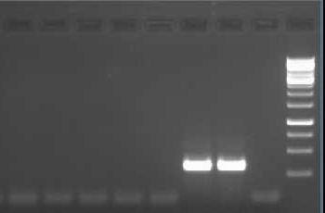
A. What do the results seen in this gel tell you? (3 pts)
1 2 3 4 5 6 7 8 9

B. What can you tell the grower based on this PCR about the identity of the causal agent of his symptoms? (2 pts)

20. Below are the results of a rt-PCR that was conducted on 7 ‘Sweetheart’ tomato seedlings that showed no virus-like symptoms. The rt-PCR used primers designed to amplify a 450 bp portion of the genome of Southern tomato virus (STV, tentative family – Amalgaviridae). Lane 1-7 are the results from each of the seedlings, lane 7 is the positive control (a known STV-infected plant), lane 8 is the PCR water blank (all PCR reagents except template and rt reagents), lane 9 is the RT water blank (the same as you conducted in lab, an aliquot of the rt reaction used as template in the PCR reaction), and lane 10 the 1 kb ladder.
1 2 3 4 5 6 7 8 9 10 110
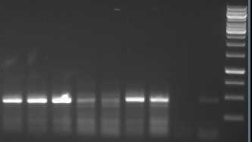
A. What do the results seen in this gel tell you? (3 pts)

B. What can you tell the seed company based on this rt-PCR about the presence of STV in his seed? (2 pts)

_____/10
21. Genetically engineered resistance using the Rep gene as a transgene gives excellent resistance against begomoviruses. However it has been observed that infection with a Crinivirus can cause the resistance to fail and render the transgenic plant susceptible. Give a likely explanation for this. (3 pts)

22. Would you expect that an insect growth regulator (this is an insecticide that prevents the immature insect from completing its life cycle by becoming an adult) would be capable of interfering with the transmission of:

A. Potato virus Y (Genus:Potyvirus), Why or why not? (2 pt)

B. Tomato mottle virus (Genus: Begomovirus),Why or why not? (2 pt)

23. Within the last month a paper was published in the journal mBio which states that the plant virus, Tobacco ringspot virus or TRSV (Genus: Nepovirus), infects honeybees and is linked to colony collapse disorder. As you may remember, TRSV is already known to be transmitted by pollen and nematodes in a semi-persistent manner.

A. What lines of evidence would the authors have to show to prove their claims? (ie give specific examples of data you would expect to see) (3 pts)

___/10

24. You are the plant pathologist at CYA Diagnostics, a company that sells reagents and kits for double antibody sandwich ELISA. Diagram below an example of one your typical ELISAs. Please illustrate a typical DAS ELISA using the symbols below to represent the different (4 pts)

PART A.

A cross section of a well in a polystyrene plate:

Symbols for Available Reagents:

Substrate
Antigen (virus sample)
Conjugated Antibody:
Rabbit anti-virus IgG
Antibody:
Rabbit anti-virus IgG
Conjugated Antibody:
Goat anti-rabbit IgG
Antibody:
Goat anti-rabbit IgG
Conjugated Antibody: Mouse anti-virus IgG
Conjugated Antibody:
Goat anti-mouse IgG
Antibody: Mouse anti-virus (monoclonal)

___/4
25. A seed company screened one hundred germplasm lines of tomato for susceptibility to Tobacco mild green mosaic virus (TMGMV), a species of Tobamovirus. Screening was accomplished by mechanical inoculation using tissue from infected tobacco plants. All inoculated plants were tested by visual assessment for symptoms and by ELISA using antisera to TMGMV. No symptoms were ever observed and TMGMV was not detected 3 weeks after inoculation of the virus. Select the mechanism that would best explain this type of resistance (Non-host resistance, Host Resistance, SAR, PTGS, PDR) and explain your reasoning. (3 pts)

26. The same company then screened twenty germplasm lines of pepper for susceptibility to TMGMV. Screening was the same as in tomato, mechanical inoculation using tissue from infected tobacco plants. All inoculated plants were tested by visual assessment for symptoms and by ELISA using antisera to TMGMV. All of the lines showed necrosis at the site of inoculation and in newly developed leaves. Plants were dead 3 weeks after inoculation. Select the mechanism that would best explain this type of resistance (Non-host resistance, Host Resistance, SAR, PTGS, PDR) and explain your reasoning. (3 pts)

_____/6
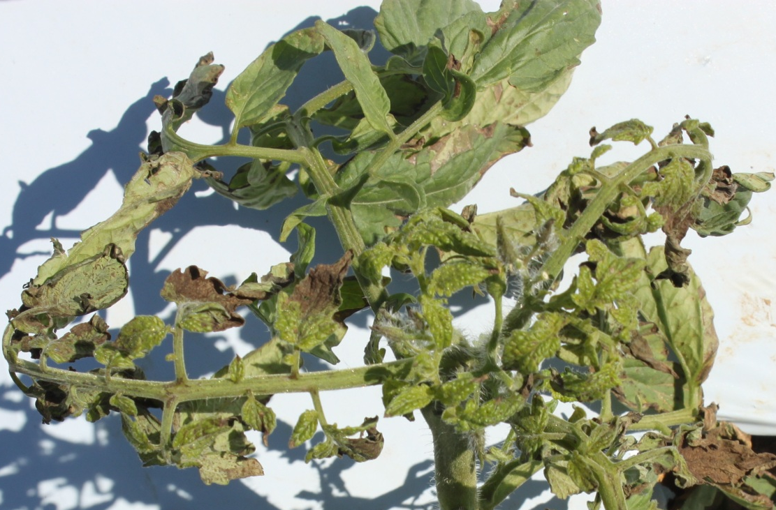
27. My laboratory received a tomato plant (shown at left before it was pulled and mailed to us) with symptoms of systemic necrosis, mottling, stunting, and leaf deformation. A number of plants in this field looked like this. I have never seen this set of symptoms before. The field was in SW Florida so whiteflies are always present. We tested it for the presence of a begomovirus using genus-specific primers and we got a positive result.
- Does this mean that a begomovirus was the cause of the symptoms? Why or why not? (1 pt)

- If you answered “No” to question A above, give two other explanations that might explain the cause of the symptoms. (2 pt)

- If you answered “No” to question A. then what do I have to do to determine the causal agent of these symptoms? Do I have to complete a modified Koch’s postulates? If not explain why not. If so, please explain what you have to do in order to determine the cause of those symptoms. (4 pt)

____/7

EXTRA CREDIT

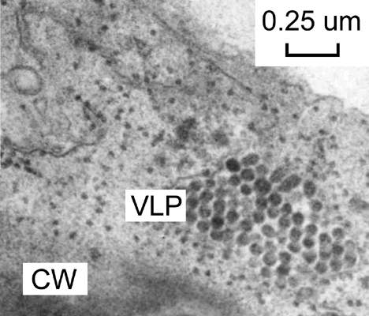
Species of the mite genus Brevipalpus transmits at least one virus in the genus Cilevirus, Citrus leprosis virus. CiLV has a segmented, bipartite, linear, ssRNA(+) genome. The virion is non-enveloped, bacilliform, about 150 nm in length and 50 nm in width, and resembles in size and shape those of rhabdoviruses (CiLV particles shown in image at right). Is there any information presented in this description that would suggest that CiLV replicates in its mite vector? If so what? (2 pts)



