FINAL EXAM 2015
PLANT VIROLOGY PLP 6223

100 TOTAL POINTS

Name: ________________

Personal Code No. : ___________

Final Exam: _____

Final Grade: _____



SECTION I. Fill in the blanks with correct word(s) or if there is a choice select the best word. (2 pts each)

1. List 3 different techniques used to detect or distinguish plant viruses that are based on the use of antibodies. _________________, _________________, ___________________.

2. In the absence of humans, list 3 different means by which viruses are able to spread over long distances: ___________________, _______________ and _______________.

3. Name two families of subviral particles that replicate without the assistance of a helper virus ______________________ and ________________________.

4. Whereas many insect-transmitted viruses move in the phloem, viruses transmitted by these insects ___________________ leave the site of inoculation via the xylem.

5. These two types of virus resistance often produce a hypersensitive response:
______________________ and _________________________.

6. Regardless of the mechanism, to be seed transmitted, a virus must be _________________________________.

7. What environmental factor has been shown to be important in determining the rate of seed transmission of a virus? ____________________________

8. Name a type of vector which does not require a stylet for transmission of plant viruses? ______________________

9. Viruses are elegant and efficient, and make the most of small genomes. Several strategies are known by which viruses are able to produce more proteins for a given length of nucleic acid than more complex organisms. Name two strategies by which they are able to do this:
__________________________ and ____________________________.

10. What is the definition of a virion? _____________________________________________________________.

11. The largest number of vector species is found among which group of vectors (circle one) aphids, beetles, thrips, nematodes, mites, or whiteflies.

____/36
SECTION II.

1. A. Many viruses are transmitted through seed despite all the obstacles presented by their plant hosts. Give 2 reasons why seed transmission is a benefit to the virus. (2 pts)

B. What is one method used to limit the impact of seed transmission in modern agriculture? (1 pt)

2. A. There are only 2 genera of plant viruses known to be transmitted by nematodes. They are:_______________ and __________________ (2 pts)

B. Which protein is produced by viruses in these 2 genera which is essential for nematode transmission of those viruses ? _____________________ (2 pts)

C. Where in the vector nematode will you find virions of these viruses that are to be transmitted? (1 pt)

3. An old hypothesis that tried to explain non-persistent transmission was known as “the stylet borne (also known as the flying needle) hypothesis” which stated that non-persistent transmission of plant viruses occurs because the plant virus is in the stylet of the insect in small amounts, and is ejected when saliva moves out of the stylet into the plant, washing the virus out of the stylet and into the plant – much like a syringe and a liquid. What information has been found that caused this hypothesis to be rejected? (2 pts)

4. Describe 3 different sources of viral nucleic acids used to obtain viral metagenomes. (3 pts)

5. Give 2 reasons why virologists use mechanical inoculation and biological indicator plants as part of the identification or diagnosis of a virus. (4 pts)

____/17
5. You are working to identify the causal agent of a new disease in okra. The symptoms in the affected hosts are virus-like. You discover that you can easily reproduce the symptoms in a healthy host by mechanical transmission using the symptomatic tissue as inoculum. However none of the insects that you have tested (aphids, whiteflies) were able to transmit an agent. You perform leaf dips in the EM but never see any virus particles. You imbed and section symptomatic plant tissue but never see viral inclusions or virus particles in the TEM.

A. What type of pathogen is the most likely cause of this disease? (2 pt)

B. Explain your reasoning. (2 pts)

C. Name an assay that you could perform that would confirm or rule out your suspicions. (2 pt)

6. You receive a sample of a plant with virus-like symptoms. After collecting all the relevant information from the grower and the literature you think you probably have a virus, although you do not know what it might be. Name 3 broad-spectrum assays that you could use to determine if there is a virus present in the symptomatic plants but absent in asymptomatic plants from the same field (3 pts).

7. A. Is the detection of a sequence of a virus in the genus Caulimovirus by PCR in a seed lot a concern on the part of the seed company? Why or why not? (2 pts)

B. What would the seed company need to do to determine if this is a problem for them? (If your answer includes running an assay include the name of the type of assay) (2 pts)

_____/13
8. You have received 5 field samples of pepper leaves with virus-like symptoms. You suspect a species of Potyvirus may be the causal agent for the symptoms based on the symptoms and that report from the grower who stated that he had seen a lot of aphids in his fields several weeks ago. You are feeling pretty confident and decide to confirm your suspicions and conduct a 2 step RT-PCR using a set of degenerate primers designed to amplify the CP region of the Potyvirus genome. Your expected amplicon size is 350 bp. You use Tobacco etch virus (TEV)-infected pepper as a positive control. Lanes 1-5 are the amplifications from each of the 5 field samples.

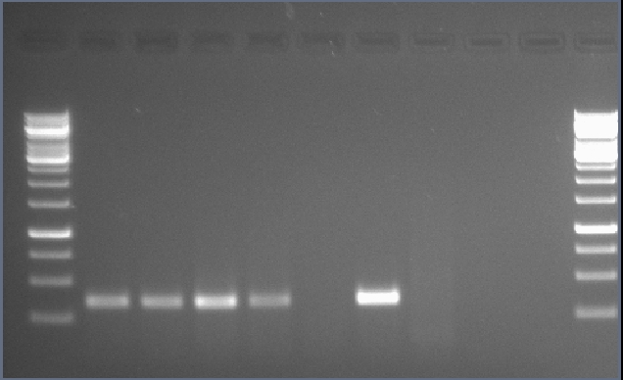
1000 bp
500 bp
750 bp
250 bp
1kb
1
2
6
7
8
9
4
5
3
1kb
Lane | Sample
1 | Sample 1
2 | Sample 2
3 | Sample 3
4 | Sample 4
5 | Sample 5
6 | TEV in Pepper
7 | Healthy Pepper
8 | RT Water Control
9 | PCR Water Control

- What does this gel tell you about the samples? (2 pts)

B. Can you advise the grower as to how to manage this disease? (1 pt)

C. If so, what can you advise him to do? If not, what do you need to do next to be able to do so? (2 pts)

_____/5

9. Genetically engineered resistance using the Rep gene as a transgene gives excellent resistance against begomoviruses. However it has been observed that infection with a Crinivirus can cause the resistance to fail and render the transgenic plant susceptible. Give a likely explanation for this. (3 pts)

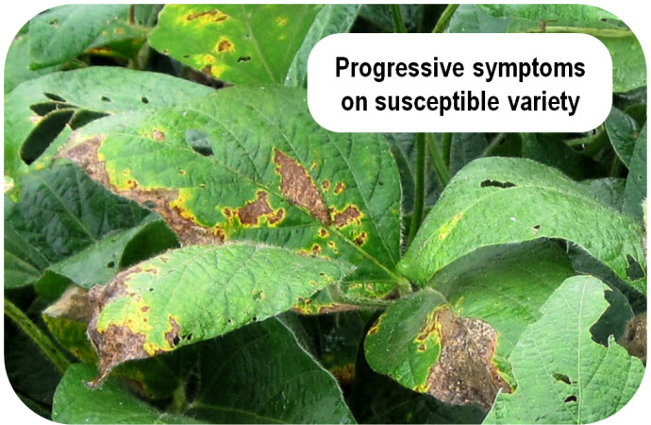
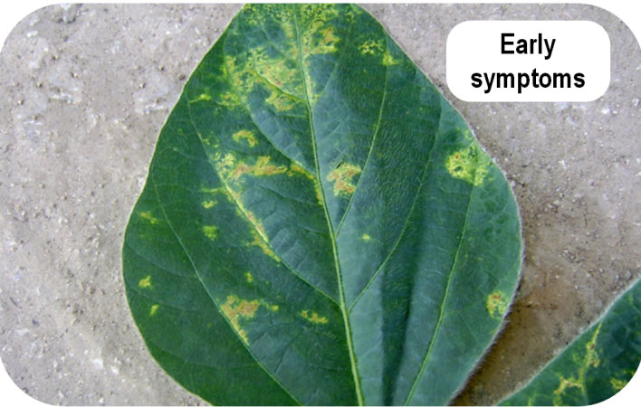
10. At right are shown the symptoms of Soybean vein necrosis virus (Bunyaviridae, Tospovirus). The symptoms begin as chlorotic spots on the leaves inoculated by its insect vectors (A). As the leaf ages, the spots become necrotic and slowly continue to enlarge to the point that the leaves desiccate, die and fall off. This can result in canopy loss.
A
B

A. Of the 5 types of plant virus interactions that were presented in lecture, which one is closest to describing what you see in this disease? (2 pt)

B. What type of within-plant movement would best account for these symptoms? Explain your answer. (2 pts)

C. What type of insect vector transmits this virus? (2 pts)

D. Where in a soybean field could you find this virus replicating? (Think carefully here – looking for 2 answers) (2 pts)

___/8
11. You are the plant pathologist at ACDiagnostics, a company that sells reagents and kits for double antibody sandwich ELISA. One of your potential customers is confused and asks for a diagram of one your typical DAS ELISAs. Please illustrate a typical DAS ELISA using the symbols below to represent the different (4 pts)

A cross section of a well in a polystyrene plate:

Symbols for Available Reagents:

Substrate
Antigen (virus sample)
Conjugated Antibody:
Rabbit anti-virus IgG
Antibody:
Rabbit anti-virus IgG
Conjugated Antibody:
Goat anti-rabbit IgG
Antibody:
Goat anti-rabbit IgG
Conjugated Antibody: Mouse anti-virus IgG
Conjugated Antibody:
Goat anti-mouse IgG
Antibody: Mouse anti-virus (monoclonal)

___/4

12. You have received an isolate of Bean golden yellow mosaic virus (BGYMV) a species of Begomovirus, in an infected plant of Phaseolus lunatus (lima bean) and you want to determine what hosts this virus can infect. You use whiteflies to try to transmit the virus from the infected lima bean to 4 spotted bean (P. maculatus) and 4 cowpea (Vigna sinensis) plants. After inoculation you kill the whiteflies and put the plants in the greenhouse to develop symptoms. After 2 weeks, you extract total nucleic acid and perform PCR using a set of specific primers designed to amplify a region of the BGYMV Rep gene. Your expected amplicon is 450 bp.

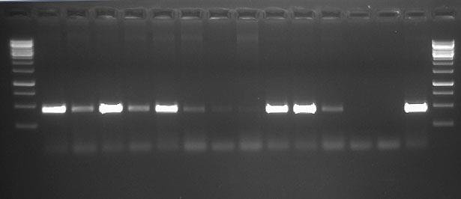
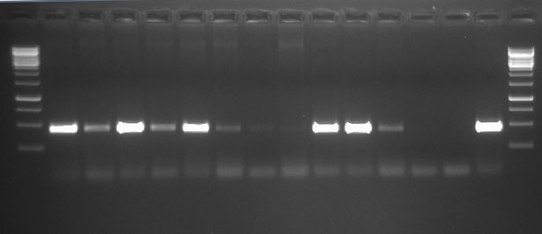
1kb
1kb
1
2
3
4
13
14
6
9
7
8
12
750 bp
1000 bp
500 bp
250 bp
11
10
5

A.

Lane | Sample
1 | Inoculated Bean 1
2 | Inoculated Bean 2
3 | Inoculated Bean 3
4 | Inoculated Bean 4
5 | Inoculated Cowpea 1
6 | Inoculated Cowpea 2
7 | Inoculated Cowpea 3
8 | Inoculated Cowpea 4
9 | Mock Inoc. Bean
10 | Mock Inoc. Cowpea
11 | Healthy Bean
12 | Healthy Cowpea
13 | PCR Water Control
14 | BGYMV-infected leaf

A. Based on your PCR results, which plants were you able to infect with BGYMV? (4 pts)

B. Amplicons from plants 1 and 3 are stronger than those from plants 2 and 4 eventhough the host is the same. Is this significant? If so what does this tell you? (1 pt)

___/5
13. Encouraged by your results you inoculate BGYMV to 11 plants of P. coccineus (scarlet runner bean), wait 2 weeks and test by PCR. Results are shown below.

750 bp
1000 bp
500 bp
250 bp
1kb
1
2
3
4
5
6
7
8
9
10
11
13
12

A. What do these results tell you about the status of P. coccineus as a host of BGYMV? Explain your answer. (2 pt)
Lane | Sample
1 | Inoculated Bean 1
2 | Inoculated Bean 2
3 | Inoculated Bean 3
4 | Inoculated Bean 4
5 | Inoculated Bean 5
6 | Inoculated Bean 6
7 | Inoculated Bean 7
8 | Inoculated Bean 8
9 | Inoculated Bean 9
10 | Inoculated Bean 10
11 | Inoculated Bean 11
12 | Uninoculated Bean
13 | BGYMV

- Based on the results of this PCR reaction, what should you do next? (2 pt)

14. A new paper just reported that resistance to CMV in tomato could be produced by the addition of Trichoderma harzianum T-22 to tomato transplant roots. T-22 is a rhizosphere microorganism and is known as an antagnostic biocontrol agent. Without further information, what type of resistance is this likely to be and why? (2 pts)

______/6

15. A seed company screened 300 germplasm lines of Capsicum chinense (habanero type pepper) for resistance to Pepper mild mottle virus (PMMoV) a virus species in the genus Tobamovirus. The screening was conducted using mechanical inoculation and tissue from infected tobacco plants. All inoculated plants were tested by visual assessment for symptoms and by ELISA using antisera to PMMoV. Approximately 3 of the genotypes responded with an HR on the inoculated leaf. Two weeks after inoculation the upper leaves of these 3 genotypes were examined for symptoms and tested by ELISA using antisera against PMMoV. No systemic symptoms were observed and there were no ELISA reactions higher than the minimum threshold (mean + 3 sd of the healthy controls).

A. Select the mechanism that would best explain this type of resistance (Non-host resistance, Host Resistance, SAR, PTGS, PDR) and explain your reasoning. (2 pts)

B. How would you prove that your answer above is correct? (2 pts)

16. Plant viruses have not been identified yet from which of these basic groups of viruses? (Circle all that apply) (2 pts)

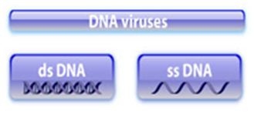
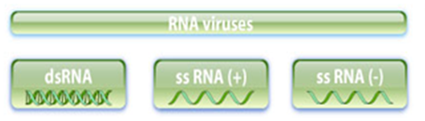



_____/6

EXTRA CREDIT
(PICK ONE)

A. One of the arguments against the use of GMO crops is the potential harm from recombination between a transgene and a challenging viral genome could produce novel viruses. Name two facts have you learned in class about genetically modified virus resistance and virus recombination that would allow you to argue against this concern? (2 pts)

Recombination happens all the time
GMO resistance usually suppresses replication in hosts so limited opportunity for recombination

B. I often stress the point that there are few commercially available antibodies that one could consider “broad spectrum”. Name 2 general approaches that theoretically someone could use to make an antibody that would be able to detect a wide range of virus species and strains within a genus. (2 pts)

Make antibodies against a viral protein that is highly conserved among difference species
Make a monoclonal antibody and screen against an array of viruses



