FINAL EXAM 2016
PLANT VIROLOGY PLP 6223

100 TOTAL POINTS

Name: ________________

Personal Code No. : ___________

Final Exam: _____

Final Grade: _____




SECTION I. Fill in the blanks with correct word(s) or if there is a choice select the best word. (2 pts each)

1. Which developmental stage(s) of a thrips can acquire a tospovirus? ________________________________

2. Which developmental stage(s) of a thrips can transmit a tospovirus? ________________________________

3. In the absence of humans, list 3 different means by which viruses are able to spread over long distances: ___________________, _______________ and _______________.

4. Antibodies are produced by _______________ cells that are present in vertebrates.

5. Whereas many insect-transmitted viruses move in the phloem, viruses transmitted by these insects __ _________ leave the site of inoculation via the xylem.

6. These two types of virus resistance often produce a hypersensitive response:
_______________________ and ________________________.

7. Regardless of the mechanism, to be seed transmitted, a virus must be _________________________________.

8. The ssRNA viruses in the genus Rhabdoviruses and Tospovirus and dsRNA viruses in the genus Reovirus both encapsidate an enzyme which is known as __________________________.

9. Name a type of vector which does not require a stylet for transmission of plant viruses? ______________________

10. Viruses are elegant and efficient, and make the most of small genomes. Several strategies are known by which viruses are able to produce more proteins for a given length of nucleic acid than more complex organisms. Name two strategies by which they are able to do this:
__________________________ and ____________________________.

11. Viruses in the genera Potyvirus, Closterovirus, and Caulimovirus are different from many other viruses in that they require a _________________________ for transmission to occur.

12. Resistance to CMV in tomato can be produced by the addition of Trichoderma harzianum T-22 to tomato transplant roots. This type of resistance is best described to be due to __________________________.
____/32
SECTION II.

1. Actigard is used to improve yields and reduce the impact of viruses on crops plants by what means? (2 pts)

2. A. There are only 2 genera of plant viruses known to be transmitted by nematodes. They are: _______________ and __________________ (1 pt ea)

B. Which protein is produced by viruses in these 2 genera that is essential for nematode transmission? ___________________ (2 pts)
CP
C. Where in the vector nematode will you find virions of these viruses that are to be transmitted? (1 pt)

D. Name one effective management approach for these viruses. (2 pt)

E. Since nematodes do not move long distances, many nematode transmitted viruses are often transmitted by ____________________which allows them to move longer distances. (1 pt)

3. Many viruses are transmitted through seed despite all the obstacles presented by their plant hosts.

A. Give 2 reasons why seed transmission is a benefit to the virus. (2 pts)

B. What is one method used to limit the impact of seed transmission in modern agriculture? (1 pt)

4. List 3 different sources of viral nucleic acids used to obtain viral metagenomes. (3 pts)

5. What are the two basic forms in which the genome of viruses move from cell to cell in their plant hosts? (4 pts)

____/20

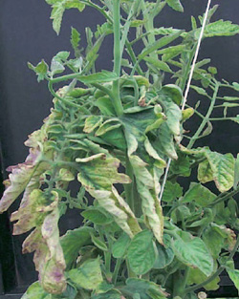
6. A greenhouse tomato grower has plants in his house that look infected with something (see right). He tells you that his plants were purchased as transplants from the Netherlands. While he only saw one or two symptomatic plants early on, he is concerned because the number of symptomatic plants is increasing rapidly. He notices that the spread seems to be down the rows. He keeps a very clean house, there are no insects or evidence of insects, and no one smokes. You conduct a leaf dip assay in the TEM and see nothing unusual. You mechanically inoculate one of the leaves to some tomato plants and within 2 weeks they are all symptomatic. Because of these results, you suspect the causal agent might be a viroid although you have no idea which one. He wants to know what he should do to contain this.

A. What would you advise him to do right away? (2 pt)

B. What would you advise him to do for the future? (2 pt)

7. A. Is the detection of a sequence of a virus in the genus Potyvirus by RT-PCR in a seed lot a concern on the part of the seed company? Why or why not? (2 pts)

B. What would the seed company need to do to determine if this is a problem for them? (If your answer includes running an assay include the name of the type of assay) (2 pts)

8. Genetically engineered resistance using the Rep gene as a transgene gives excellent resistance against begomoviruses. However, it has been observed that infection with species of Crinivirus can cause the resistance to fail and render the transgenic plant susceptible to the begomovirus. Give a likely explanation for this. (2 pts)

_____/10
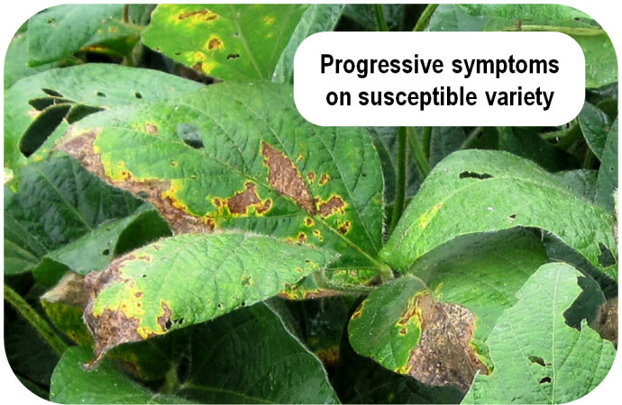
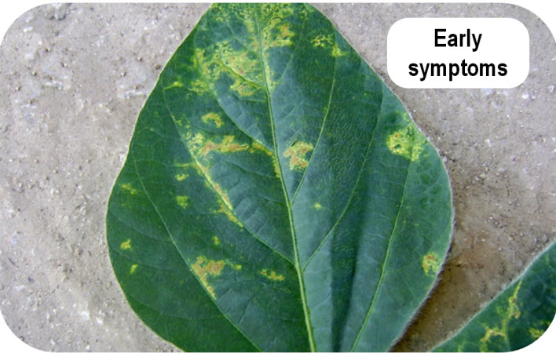
9. At right are shown the symptoms of Soybean vein necrosis virus (Bunyaviridae, Tospovirus). The symptoms begin as chlorotic spots on the leaves inoculated by its insect vectors (A). As the leaf ages, the spots become necrotic and slowly continue to enlarge to the point that the leaves desiccate (B), die and fall off. This can result in canopy loss.
A
B

A. Of the 5 types of plant virus interactions that were presented in lecture, which one is closest to describing what you see in this disease? (2 pt)

B. What type of within-plant movement would best account for these symptoms? Explain your answer. (3 pts)

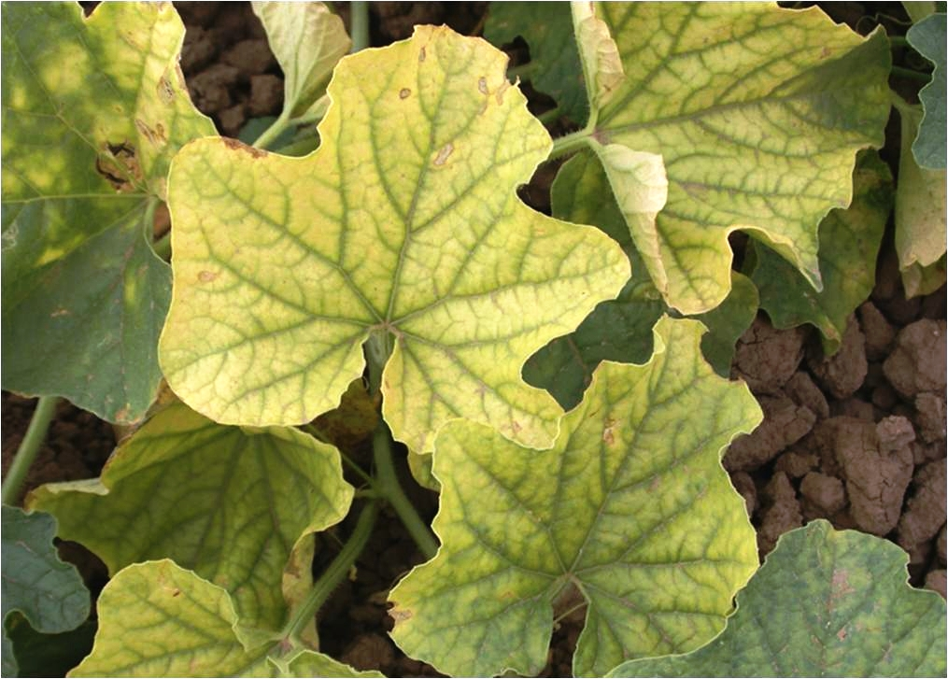
10. Resistance has been found in one accession of melon (Cucumis melo L.), to Cucurbit yellow stunting disorder virus (CYSDV; Closteroviridae, genus Crinivirus) (Right: susceptible infected plant). Resistance is controlled by a single recessive gene, inoculated plants never show any local or systemic symptoms. CYSDV can be detected in systemically infected leaves but at much lower levels than susceptible genotypes.

Name one normal virus function with which this gene is most likely interfering and provide your reasoning for the selection. (2 pts)

11. Many plant viruses are known to have satellites. Describe (and distinguish) the 3 types of satellites that are dependent upon a plant virus for replication. (6 pts)

_____/13

12. You are the plant pathologist at BioReba, a company that sells reagents and kits for double antibody sandwich ELISA. One of your potential customers is confused and asks for a diagram of one your typical DAS ELISAs.

- Please illustrate a typical DAS ELISA using the symbols below to represent the different components (4 pts)

[Right: A cross section of a well in a polystyrene plate]

Available Reagents:
Substrate
Antigen (virus sample)
Conjugated Antibody:
Rabbit anti-virus IgG
Antibody:
Rabbit anti-virus IgG
Conjugated Antibody:
Goat anti-rabbit IgG
Antibody:
Goat anti-rabbit IgG
Conjugated Antibody: Mouse anti-virus IgG
Conjugated Antibody:
Goat anti-mouse IgG
Antibody: Mouse anti-virus (monoclonal) IgG
- Then the customer says that he wants you to design for him a more sensitive ELISA assay than the one you just showed him. Is that possible? If so, how would you do design the new assay? (4 pts)

__/8
13. A seed company screened 300 germplasm lines of Capsicum chinense (habanero type pepper) for resistance to Pepper mild mottle virus (PMMoV) a virus species in the genus Tobamovirus. The screening was conducted using mechanical inoculation and tissue from infected tobacco plants. All inoculated plants were tested by visual assessment for symptoms and by ELISA using antisera to PMMoV. Approximately 3 of the genotypes responded with an HR on the inoculated leaf. Two weeks after inoculation the upper leaves of these 3 genotypes were examined for symptoms and tested by ELISA using antisera against PMMoV. No systemic symptoms were observed and there were no ELISA reactions higher than the minimum threshold (mean + 3 sd of the healthy controls).

A. Select the mechanism that would best explain this type of resistance (Non-host resistance, Genetic host resistance, SAR, PTGS, PDR) and explain your reasoning. (2 pts)

14. It has been shown for Cauliflower mosaic virus (but is probably true for many others), that the pattern of movement of a virus through a plant follows the same pathway as that of host ________________________. (2 pts)

15. The way a virus is distributed among leaves and within a leaf affects more than just the success of virus detection. How does virus distribution in a plant affect the rate at which insect vectors acquire virus in a non-persistent manner? (2 pts)

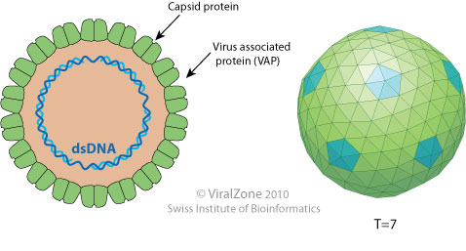
16. In 2015 a new genus, Rosednavirus, was added to the list of described plant virus genera.
Species in this genera are monopartite, and have a particle like that shown in the figure on the right. Their genomes are open circular, double stranded DNA. To what family do they belong? (3 pts)

_____/9

17. Practices used to manage diseases caused by viruses fall into three general (broad) categories. Name one category and describe 3 different practices from that category that are used successfully. (4 pts)

18. Poinsettia latent virus is the type member of the genus Polemovirus (family unassigned). Diagrams of the virion and genome are shown below.

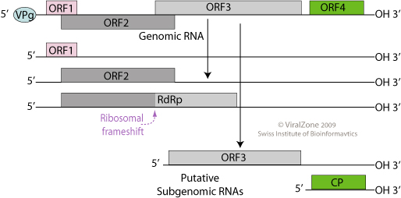
VIRION GENOME
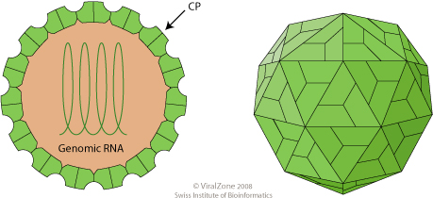

What type and sense of the nucleic acid of the genome of Poinsettia latent virus? (3 pts)

Is the genome monopartite or multipartite? (1 pt)

_______/8

EXTRA CREDIT
(PICK ONE)

A. One of the arguments against the use of GMO crops is the potential harm from recombination between a transgene and a challenging viral genome could produce novel viruses. Name two facts have you learned in class about genetically modified virus resistance and virus recombination that would allow you to argue against this concern? (2 pts)

B. I often stress the point that there are few commercially available antibodies that one could consider “broad spectrum”. Name 2 general approaches that theoretically someone could use to make an antibody that would be able to detect a wide range of virus species and strains within a genus. (2 pts)

______/2


