FINAL EXAM 2017
PLANT VIROLOGY PLP 6223

100 TOTAL POINTS

Name: ________________

Personal Code No. : ___________

Final Exam: _____

Final Grade: _____

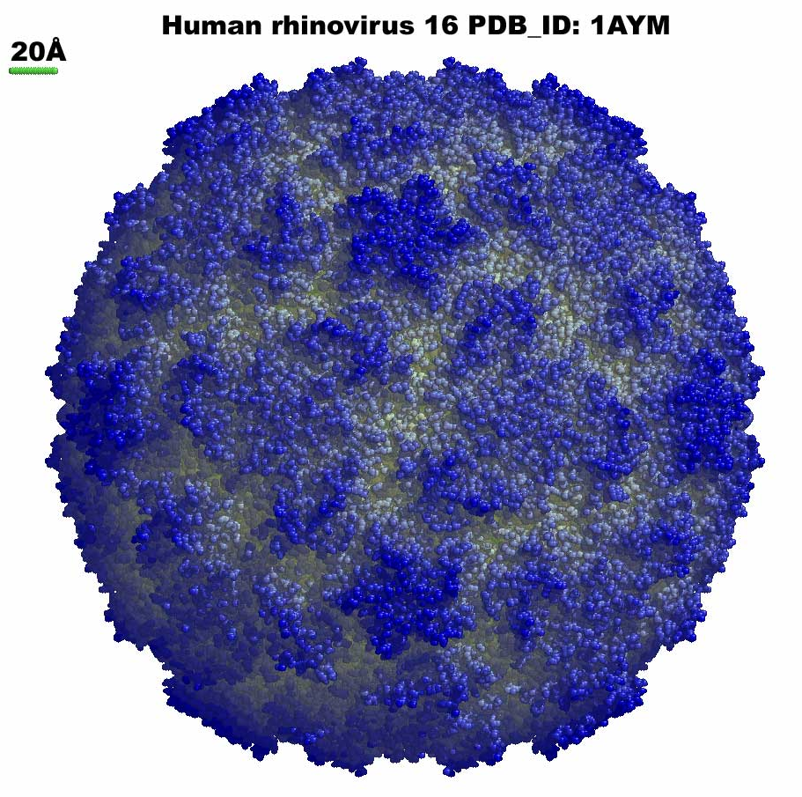
SECTION I. Fill in the blanks with correct word(s) or if there is a choice select the best word. (2 pts each)

1. In the absence of humans, list 3 different means by which viruses are able to spread over long distances: ___________________, _______________ and _______________.

2. The ________________ (a viral protein) plays a direct role in transmission of plant viruses by beetles.

3. A lateral flow assay is based on the detection of viral nucleic acids or viral proteins (circle one).

4. Antibodies are produced by _______________ cells that are present in vertebrates.

5. Whereas many insect-transmitted viruses move in the phloem, viruses transmitted by these insects ___________________ leave the site of inoculation via the xylem.

6. It has been shown for Cauliflower mosaic virus (but is probably true for many others), that the pattern of movement of a virus through a plant follows the same pathway as that of host ________________________.

7. These two types of virus resistance often produce a hypersensitive response:
_________________________ and ___________________________.

8. Regardless of the mechanism, to be seed transmitted, a virus must be _________________________________.

9. The ssRNA viruses in the genus Rhabdoviruses and Tospovirus and dsRNA viruses in the genus Reovirus both encapsidate an enzyme which is known as __________________________.

10. Some resistance mechanisms have a systemic signal so that infection on one leaf confers resistance in other parts of the plant never exposed to virus. The systemic signal in SAR is thought to be (at least in part) ________________ and the systemic signal in PTGS is ____________________.

11. What is the current name for viral genes, that were once known as pathogenicity genes, that reproduce the symptoms of the virus when expressed in plants using a transient vector or through transformation of the plant’s genome?_____________________________.

12. What is the most effective assay to detect seed transmission of a virus?
___________________________

____/28
13. Viruses in the genera Potyvirus, Closterovirus, and Caulimovirus are different from many other viruses in that they require a _________________________ for transmission to occur.

14. Resistance to CMV in tomato can be produced by the addition of Trichoderma harzianum T-22 (a PGPR – plant growth promoting rhizobacteria) to tomato transplant roots. This type of resistance is known as: _____________________.

SECTION II.

1. A. Actigard is used to improve yields, reduce drought stress, and reduce the impact of viruses on crops plants by what means? (2 pts)

B. List one significant limitation to the use of Actigard to manage plant viruses. (2pts)

2. There are three types of induced or active responses by the plant to infection by virus. List two types and compare and contrast. (4 points)

3. A. Three genera of nematodes are known to transmit plant viruses, two of those genera are: (2 pts)

B. Which protein, produced by nematode-transmitted viruses, is essential for nematode transmission? ___________________ (2 pts)

C. Where in the vector nematode will you find virions of these viruses that are to be transmitted? (1 pt)

D. Name one effective management approach for these viruses. (2 pt)

E. Since nematodes do not move long distances, many nematode transmitted viruses are often transmitted by ____________________which allows them to move longer distances. (1 pt)

____/20
4. Give 2 reasons why seed transmission of viruses is significant from the perspective of the virus. (2 pts)

5. List 3 different forms of plant viral nucleic acids used to obtain viral metagenomes. (3 pts)

6. What are the two basic forms in which the genome of viruses move from cell to cell in their plant hosts? (4 pts)

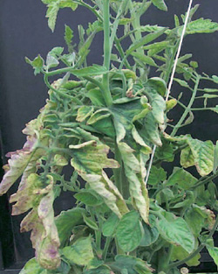
7. A greenhouse tomato grower has plants in his house that look infected (see figure to the right). He tells you that his plants were purchased as transplants from the Canada. While he only saw one or two symptomatic plants within a week after transplant, he is concerned because the number of symptomatic plants is increasing weekly, and he notices that the spread seems to be mostly down the rows. He keeps a very clean house, there are no insects or evidence of insects, and no one smokes. You conduct a leaf dip assay in the TEM and see nothing unusual. You mechanically inoculate one of the leaves to 5 tomato plants and within 2 weeks they are all symptomatic. Because of these results, you suspect the causal agent might be a viroid although you have no idea which one.

A. What would you advise him to do right away? (2 pt)

B. What assay would you recommend be used to confirm the presence of a
(possibly) new and undescribed viroid? (2 pt)

8. If you had an antibody to TYLCV coat protein, circle two locations (from those listed below) where you would most likely be able to detect this protein in a viruliferous whitefly vector. Since antibody assays are not as sensitive as PCR, these would be locations of highest concentration of the coat protein. (2 pts)
Hemocoel, salivary glands, filter chamber, muscle tissue, eggs

____/15
9. One of the arguments against the use of GMO crops is the potential harm from recombination between a transgene and a challenging viral genome could produce novel viruses. Name two facts have you learned in class about genetically modified virus resistance and virus recombination that would allow you to argue against this concern? (2 pts)

10. You have learned that plant viruses are elegant and efficient entities, and make the most of small genomes. Several strategies are known by which viruses are able to produce more proteins for a given length of nucleic acid than more complex organisms. List two strategies by which they are able to do this. (2 pts)

11. Below is a figure illustrating the Baltimore Viral Classification Scheme proposed by David Baltimore, Nobel laureate in Physiology or Medicine. You are familiar with viruses in several of these categories. What should be written in the center box? You will need to be specific for full credit. (2 pts)
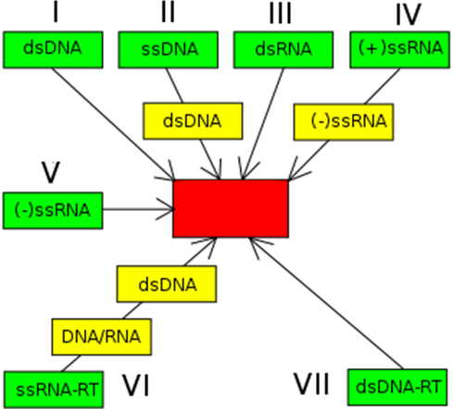

12. Genetically engineered resistance using either complete or partial viral genes as transgenes gives excellent resistance against viruses from with the genes were obtained. However, it has been observed that infection with other viruses can cause the resistance to fail and render the transgenic plants susceptible to the target virus. Give a likely explanation for this. (2 pts)

_____/8
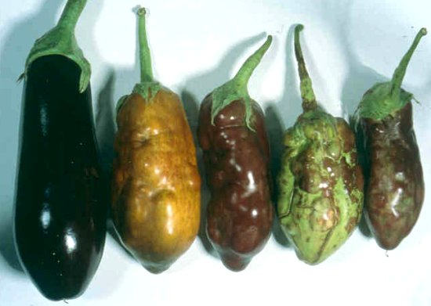
13. You work in the UF virology lab and one day you receive a sample of an eggplant that appears to have virus-like symptoms. [the fruit on the left is healthy, the other fruit are from symptomatic plants]. The leaves are chlorotic and distorted, and the plants are stunted. You send the plant sample to AgDia and ask them to run their array of ELISAs for solanaceous crop viruses. Two weeks later you get results back that the sample was positive for Tomato bushy stunt virus, a Tombusvirus. This virus has never been reported in Florida before, but is a problem in tomato in California, Virginia, and parts of Europe. The symptoms you see in the fruit and plant are similar to those reported from other locations.
You would like to publish the results so that others in the state (growers, scouts, researchers, extension agents) will know that this virus now occurs here and how to recognize the symptoms. What is the minimum that you need to do in order to publish a Disease Note in Plant Disease (according to the Plant Disease, Instructions to Authors)? Select one of the answers below and explain your reasoning. (4 pts)

A. Conduct another assay such as RT-PCR followed by sequence analysis or mechanical inoculation to indicator species.
B. Complete a modified Koch’s postulates.
C. Both A and B
D. No need to do anything, you can publish what you have. Start writing!
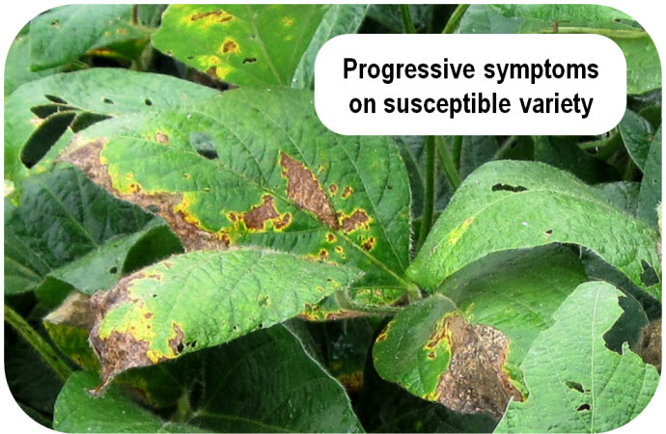
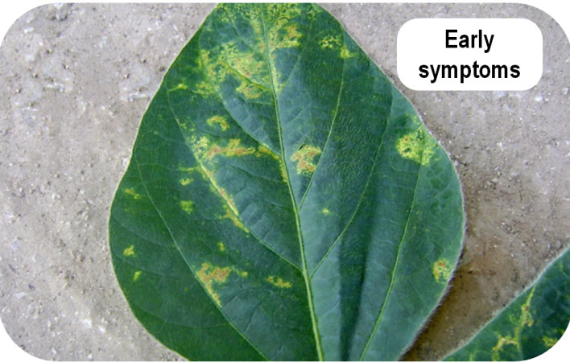
A
B
14. Symptoms of Soybean vein necrosis virus (Bunyaviridae, Tospovirus) in soybean are shown (right). Symptoms begin as chlorotic spots on the leaves that are inoculated by thrips (Fig. A). As the leaf ages, the spots become necrotic and slowly enlarge to the point that the leaves desiccate (Fig. B), die and fall off. This results in canopy loss.
A. Of the 5 types of plant virus interactions that were presented in lecture, which one is closest to describing what you see in this disease? (2 pt)

B. What type of within-plant movement would best account for these symptoms? Explain your answer. (2 pts)

___/8
15. You are the plant pathologist at Bubba’s Antibodies, a company that sells reagents and kits for double antibody sandwich ELISA. One of your potential customers is confused and asks for a diagram of one your typical DAS ELISAs.

- Illustrate a typical DAS ELISA in the figure to the right, using the symbols below to represent the different components (4 pts)
[Right: A cross section of a
well in a polystyrene plate]

Available Reagents:

Substrate
Antigen (virus sample)
Conjugated Antibody:
Rabbit anti-virus IgG
Antibody:
Rabbit anti-virus IgG
Conjugated Antibody:
Goat anti-rabbit IgG
Antibody:
Goat anti-rabbit IgG
Conjugated Antibody: Mouse anti-virus IgG
Conjugated Antibody:
Goat anti-mouse IgG
Antibody: Mouse anti-virus (monoclonal) IgG
Then the customer says that he wants you to design for him a more sensitive ELISA assay than the one you just showed him.

Indicate at right, what reagents you would use and in what order for the new assay. (4 pts)

__/8
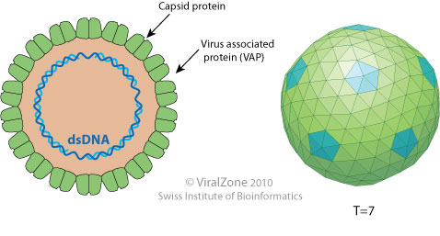
16. In 2015 a new genus, Rosednavirus, was added to the list of described plant virus genera.
Species in this genera are monopartite, and have a particle like that shown in the figure on the right. Their genomes are open circular, double stranded DNA. To what family do they belong? (3 pts)

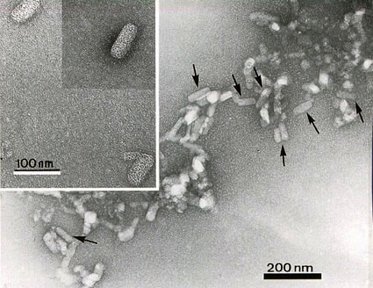
17. A few years ago a new virus was reported to cause a disease in citrus. Virus particles were seen (see picture at right) from leaf dips by negative staining. Before obtaining any sequence, the researchers reported that this virus was a new species in the family Rhabdoviridae. (True story)

A few years later, the virus was fully sequenced and a genome organization (see below) was proposed.

In your opinion (based on what you see here and what you know about viruses in the Rhabdoviridae) does this virus species belong in the Rhabdoviridae?

Why or why not? (be specific please) (4 pts)

18. You are working on a new disease in avocado in Florida which is characterized by virus-like symptoms. The symptoms are similar to those caused by a virus, and you cannot associate any bacteria or fungus with the disease. Therefore you suspect the causal agent might be a new virus. Therefore you decide to run a couple of assays. Name two broad-spectrum assays that you would use to detect a virus (remember you don’t know what this virus might be). (2 pts)

____/9
18. Citrus psorosis virus is the type member of the genus Ophiovirus (family unassigned). Diagrams of the virion and genome from Viral Zone are shown below.

VIRION: GENOME ORGANIZATION:

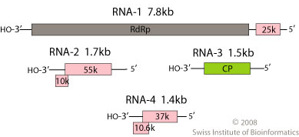


What is the type and sense of the nucleic acid of the genome? (2 pts)

Is the genome monopartite or multipartite? (1 pt)

- Is the virion monopartite or multipartite? (1 pt)

____/4

EXTRA CREDIT

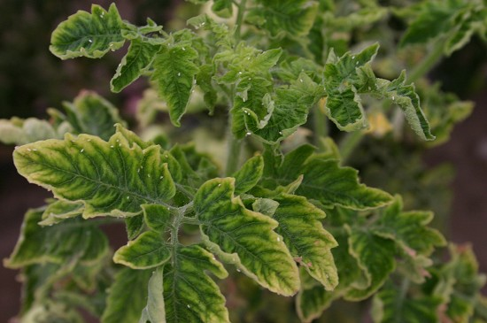
(True story) There is resistance deployed to TYLCV provided by 2 genes, Ty-1 and Ty-3. Ty-1 and Ty-3 are allelic and they code for a RNA–dependent RNA polymerase. Recently in Israel, TYLCV has been found to overcome the resistance, and in each case there is a Beta satellite present in the plants where resistance was overcome. Based on these results what would you guess the mechanism of resistance is most likely to be? Please explain your answer. (2 pts)

+____/2



