MIDTERM EXAM
PLANT VIROLOGY

Jan 31/Feb 3, 2014

Name: ________________

Personal Code No. : ___________

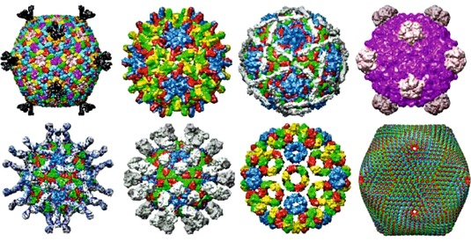
SECTION I. Fill-in-the-Blank (Section totals 34 points).
Fill in the blanks with correct word(s) or if there is a choice circle the correct word(s). (2 points for each correct answer)

1. The ICTV requires that you obtain the complete ________________ of a virus before they will consider accepting it as a new virus species.

2. Like the names of other species, approved virus names are recognized by the use of _________________________?

3. Viruses use multiple copies of the same molecule for their capsid, this is done for several reasons, name two: _____________________ and ______________________.

5. Unlike animal and bacterial viruses, plant viruses lack an active mechanism to invade plant cells. This is because plant cells, unlike animal and bacterial cells, have thick __________________ that block virus invasion.

6. To initiate an infection in a plant, a plant virus must enter plant cells via ___ _____________ which can occur in various ways.

7. Plant viruses that have DNA genomes have higher/lower/similar rates of mutation compared to their plant hosts? (circle your choice)

8. Genome recombination can result in the following types of changes in a virus’s genome: _________________, ___________ , and ___________________.

9. Potyviruses have only one open reading frame but are still able to produce a wide area of proteins. They do this through what process? __________________

10. Negative staining is a technique used to visualize virus particles in the electron microscope. The negative stain we used in lab was ______________. While several materials can be used as negative stains, what characteristic is essential to a negative stain for use in the EM? _____________________

12. A lateral flow assay detects viral proteins/viral nucleic acids (circle one).

13. Usually plant viruses replicate either in the cytoplasm or the nucleus – give an example of a genus of viruses the replicates in the cytoplasm __________________, replicates in the nucleus ____________________.

14. Viruses that have _________________ genomes code for their own polymerase, which is the first gene that is transcribed and translated.

_____/34

SECTION II. Short Answer

1. Even though the genera Tospovirus and Cytorhabdovirus have been placed in different families, they have several characteristics in common. Name 3 characteristics shared by virus species in these two genera. (6 pts)

2. There are many types of satellites that depend upon a plant virus for their replication. Name the 3 types and distinguish one from the other (6 pts)

3. Coat protein is an essential component of most plant viruses but is not expressed in the same way by all viruses even those with the same sense and type of genome. (4 pts)

- For viruses in the genus Potyvirus, the coat protein is expressed from the _____________ RNA.

- For viruses in the genus Tobamovirus, the coat protein is expressed from a _________________________ RNA.

4. There is a virus species in the genus Tobamovirus known as wasabi mottle virus (no really there is!) (3 pts)
A. Is the name written correctly?
B. If not, please write it correctly.

5. Beijerinck and the other viral pioneers in the late 1800’s through the 1950’s could be considered lucky to have started working on the mosaic disease of tobacco. But was it really luck? Other viruses were studied at the same time, and in fact you don’t hear much about them and none of them had the impact that TMV did.
Describe three characteristics of TMV that made it likely that this virus would be the one to permit the recognition of all viruses? (6 pts)

______/25

6. All viruses can be divided into seven classes on the basis of differing strategies for storing and replicating their genomes through RNA and/or DNA intermediates. To date, we only know of plant viruses that use five of the seven classes of replication. Indicate which of the five classes of replication are known to occur with plants viruses by giving one example of a virus family for each class of replication (indicate with an arrow to connect the name of the family with the class of replication) (10 pts)

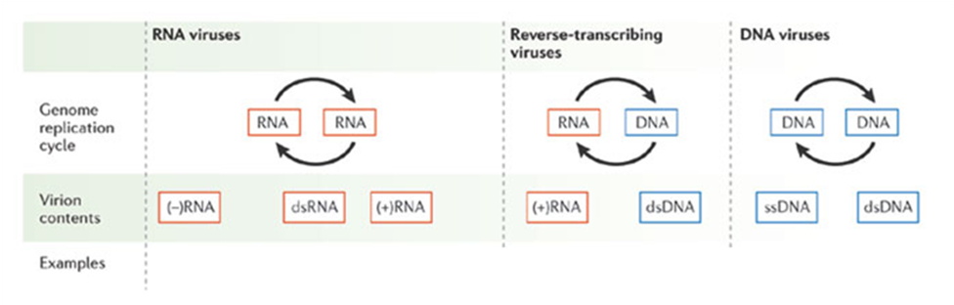

7. Below are two diagrams of the genome organization and strategy of protein expression of ssRNA viruses in the genus Varicosavirus.

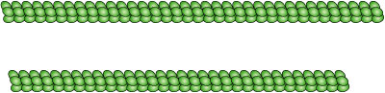

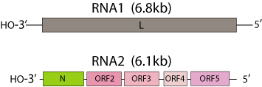

- Circle the virion. (1 pt)
- What sense is the RNA1 genome segment (2 pt)?
- What sense is RNA2 genome seqment? (2 pt)

____/15
8. To improve your success rate of mechanical inoculation, name 3 variables that you must optimize. (3 pts)

9. The genome organization and particle structure of European mountain ash ringspot associated virus (Emaravirus) are shown below.

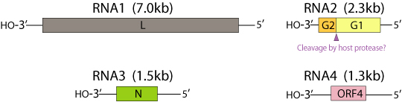
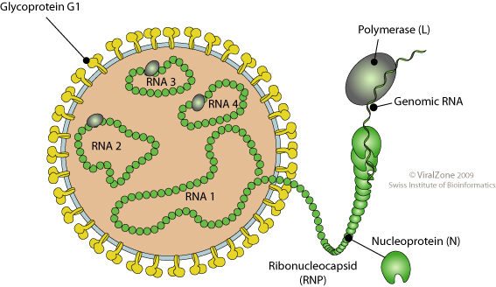

A. What sense is the viral genome (2 pt)?

B. What is the best term to describe the shape of this virion? What is your reasoning? (2 pt)

C. Would you expect this virus to have an insect vector? Why or why not? (2 pts)

____/9

10. Viruses evolve rapidly over time. This results in their ability to exploit new hosts and to overcome host resistance. List and briefly describe 3 mechanisms that allow viruses to adapt to changing environments. (6 pts)

11. You think that you have found a new species of Tospovirus in watermelon based on the virion size and shape (as seen with the EM), inclusion body as seen with the light microscope, and association with high populations of thrips. Since you are familiar with the Tospovirus replication strategy, give the specific names of 3 proteins that you know that the new virus will have to produce. (2 pt each, 6 pts total)

12. List 3 methods used to store plant viruses for multiple years. (3 pts)

13. What is viral metagenomics? (2 pt)

_____/17

