FIRST EXAM
PLANT VIROLOGY

March 30 2015

Name: ________________

Personal Code No. : ___________

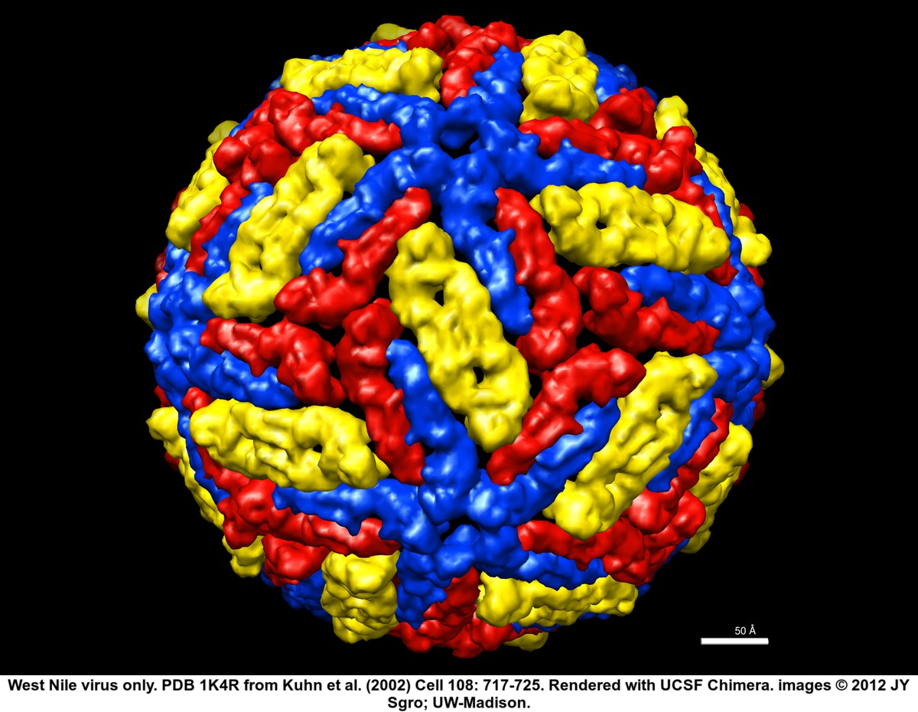

SECTION I. Fill-in-the-Blank (Section totals 36 points).

Fill in the blanks with correct word(s) or if there is a choice circle the correct word(s). (2 points for each correct answer)

1. Viruses move from cell to cell in one of two forms which are either _______________ or _________________________.

2. Some viruses have been shown to be capable of integrating parts of or entire genomes and even multiple copies of their genomes into the host’s genome. This is known to occur with at least two plant viruses families, name one: _________________.

3. Viruses use multiple copies of the same molecule for their capsid, this is done for several reasons, name two: _____________________ and ______________________.

4. Unlike animal and bacterial viruses, plant viruses lack an active mechanism to invade plant cells. This is because plant cells, unlike animal and bacterial cells, have thick ____ ___________ that block virus invasion.

5. Members of 2 RNA virus families that we studied, _____________ and _______________ express at least some of their viral proteins via proteolytic processing?

6. To initiate an infection in a plant, a plant virus must enter plant cells via ___ ___________________ which can occur in various ways.

7. Reoviruses cause some unusual symptoms in plants – one of those unusual symptoms would be _________________________.

8. Many plant viruses replicate in the cytoplasm - give two examples of plant virus genera that replicate in the cytoplasm __________________, and _________________.

9. Many plant viruses replicate in the cytoplasm - give two examples of plant virus genera that replicate in the nucleus __________________, and _________________.

10. Viruses that have _________________ genomes code for their own polymerase, which is the first gene that is transcribed and translated.

11. One of the main differences between the 2 families of viroids is the location of their replication. Viroids in the Pospiviroidae replicate in the ____________________ and those in the Asunviroidae replicate in the _________________.

12. The ICTV requires that you obtain the complete ___________________ of a virus before they will consider accepting it as a new virus species.

_____/36

SECTION II. Short Answer (section total 68 pts)

1. Provide 3 characteristics that taken together will distinguish a viroid from all other mobile genetic elements? (3 pts)

2. There are many types of satellites that depend upon a plant virus for their replication. Name the 3 types and distinguish one from the other (6 pts)

3. Coat protein is an essential component of most plant viruses but is not expressed in the same way by all viruses even those with the same sense and type of genome. (4 pts)

- For viruses in the genus Potyvirus, the coat protein is expressed from the _____________ RNA.

- For viruses in the genus Tobamovirus, the coat protein is expressed from a _________________________ RNA.

4. There is a virus species in the genus Tenuivirus known as zombiefolia mottle virus (4
pts)
A. Is the name written correctly?

B. If not, please write it correctly.

5. To improve your success rate of mechanical inoculation, name 3 variables that you must optimize. (3 pts)

6. You think that you have found a new species of Rhabdovirus in tomato based on the virion size and shape (seen with the EM), and association with high populations of aphids. Since you are familiar with the Rhabdovirus replication strategy, give the specific names of 3 proteins that you know that the new virus will have to produce. (2 pt each, 6 pts total)

___/26

7. Below is a diagram of the virion of Grapevine leafroll-associated virus 7 in the new genus Velarivirus. The genome is 16-17 kb, with no poly A tail, and encodes 10 proteins. The virion is about 1500-1700 nm long and has a major and minor coat protein.

VIRION
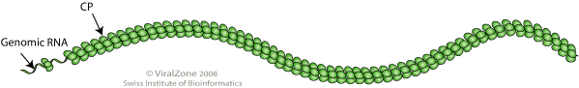

GENOME
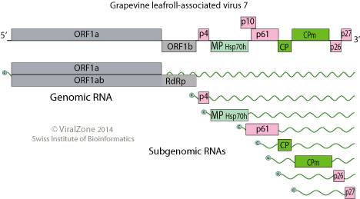
- What is the best term to describe the shape of this virion? (2 pt)

- What sense is the RNA genome (2 pt)?

- From the list below, circle all the strategies that this virus is using to express its proteins (based on what you can see in the diagram). (4 pts)
subgenomic RNAs,
multipartite genomes
polyprotein
translational read-through
translational frame-shift
ambisense RNAs

- What family do you think that this genus should be placed in? Explain your reasoning.(3 pts)

____/11
8. I purify what I think is a new RNA virus from a symptomatic plant. When I view the purified virus in an electron microscope I see 2 different sized virus-like icosahedral particles. Which of the following could explain the reason for this? (7 pts)

a) I have a mixed infection of 2 different viruses
b) I have a virus with a satellite virus
c) I have a virus with a dependent RNA nucleic acid
d) I have a virus with a defective interfering RNA
e) I have a virus with a defective interfering DNA
f) I have a virus and a viroid
g) I have a multicomponent virus

9. A. In the image below, what family of plant viruses does this replication cycle most closely resemble? (3 pts)

B. Is this virus enveloped or non-enveloped? (1 pt)
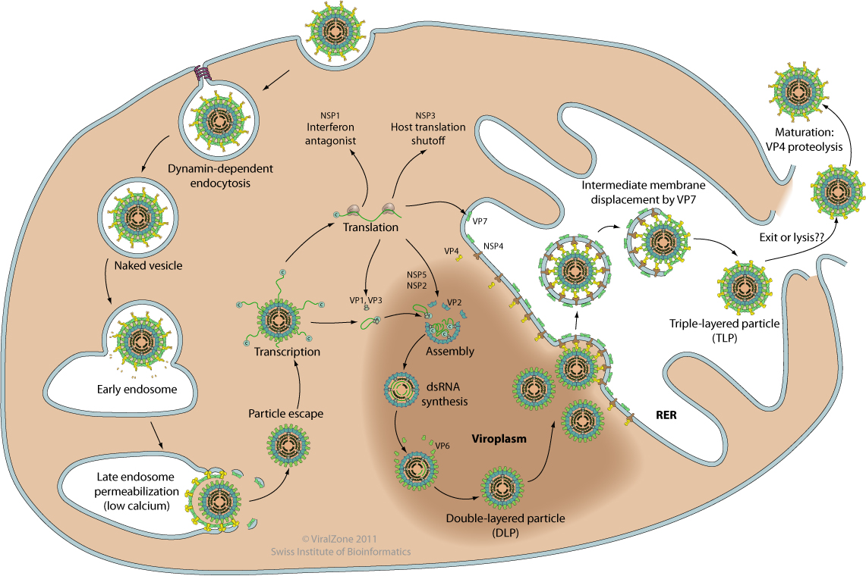

_____/11
10. The protein expression strategy of a family of viruses is represented in the image below.
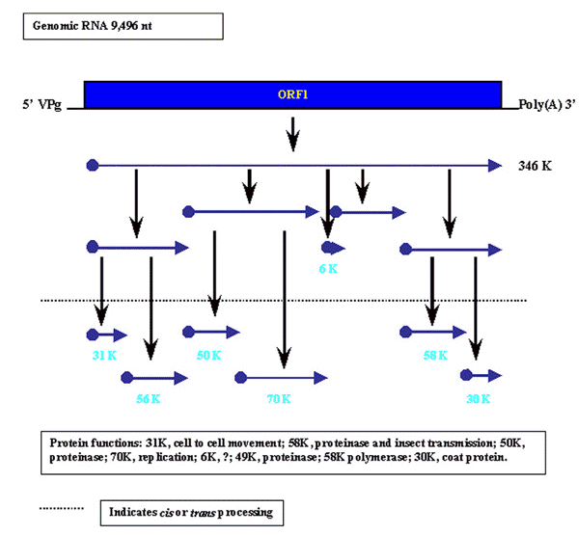

A. What is the strandedness of this RNA genome? (2 pts)

B. What is the polarity of this RNA genome? (2 pts)

C. Smaller proteins are cleaved from the larger proteins by what process? (3 pts)

D. Is this cleavage controlled by the host or by the virus? (3 pts)

11. What is an endogenous plant pararetrovirus sequence (EPRV)? (3 pts)

12. What role(s) can endogenous plant pararetrovirus sequences play in plant disease? (3 pts)

_______/16 points

EXTRA CREDIT

What protein is produced by both pararetroviruses and retrotransposons? (2 pts)

