FIRST EXAM
PLANT VIROLOGY

February 15 2016

Name: ________________

Personal Code No. : ___________

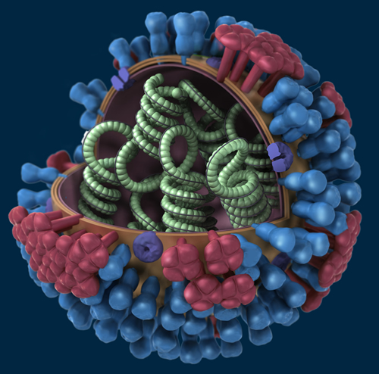

SECTION I. Fill-in-the-Blank (Section totals 30 points).

Fill in the blanks with correct word(s) (2 points for each correct answer)

1. Viruses in the Reoviridae cause some unusual symptoms in plants – one of those unusual symptoms would be ________ ________________.

2. Some viruses have been shown to be capable of integrating parts of or entire genomes and even multiple copies of their genomes into the host’s genome. This is known to occur with at least two plant virus families, name one: _________________.

3. Viruses use multiple copies of the same molecule for their capsid, this is done for several reasons, name two: _____________________ and ______________________.

4. An enveloped virus has a _____________________ that is derived from its host.

5. Give the name of 2 plant virus families that express at least some of their viral proteins via proteolytic processing, ___________________ and __________________.

6. Many plant viruses replicate in the cytoplasm - give two examples of plant virus genera that replicate in the cytoplasm __________________ and ______________.

7. Viruses that have _______________ genomes code for their own polymerase, which is the first gene that is transcribed and translated.

8. One of the main differences between the 2 families of viroids is the location of their replication. Viroids in the Pospiviroidae replicate in the ____________________ and those in the Avsunviroidae replicate in the _________________.

9. The ICTV requires that you obtain the complete ___________________ of a virus before they will consider accepting it as a new virus species.

10. What are the 2 most critical considerations for long term storage of plant viruses in tissue? _________________ and _____________________.

_____/30

SECTION II. Short Answer (section total 70 pts)

1. Which of the following can induce symptoms in plants? (4 pts)

Plasmids Viruses Viroids Transposons Prions Satellites

2. Plant virus species are not named using a binomial nomenclature system like fungi or bacteria or plants. How is the name of a virus species created (ie what are the 3 essential components in the approved name of a virus species? (1 point ea., 3 pts total)

3. Give the name of two families of mobile genetic elements that employ a rolling circle mechanism for their replication. (4 pts)

4. Provide 3 characteristics that taken together will distinguish a viroid from all other mobile genetic elements? (3 pts)

5. There are many types of satellites that depend upon a plant virus for their replication. Name the 3 types and distinguish one from the other (6 pts)

6. It takes about 2-3 weeks after inoculation for symptoms to be visible in a susceptible plant. Why is this? (3 pts)

___/23

7. You think that you have found a new species of Begomovirus in tomato based on the virion size and shape (seen with the EM). Since you are familiar with the Begomovirus replication strategy, give the specific names of 3 proteins that you know that the new virus will have to produce. (2 pt each, 6 pts total)

8. Below is a diagram of the virion of Olive latent virus 2 in the genus Oleavirus, family Bromoviridae. The virion is composed of 3 (sometimes 4) non-enveloped, quasi-spherical particles, that are 18 nm wide and either 37, 43, 48 or 55 nm long).

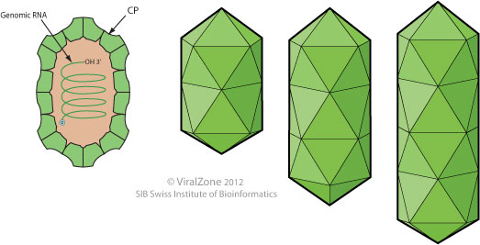
VIRION: GENOME:
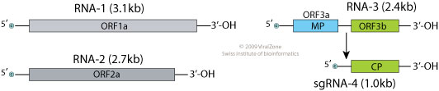

- What is the best term to describe the morphology of this virus? (3 pt)

- What sense is the RNA genome (3 pt)?

- Indicate which RNA genome segment fits in which particle. (3 pts)

- From the list below, circle all the strategies that this virus is using to express its proteins (based on what you can see in the diagram). (3 pts)

subgenomic RNAs,
multipartite genome
polyprotein
translational read-through
translational frame-shift
ambisense RNA

____/18
9. I purify what I think is a new RNA virus from a symptomatic plant. When I view the purified virus in an electron microscope I see 2 different sized virus-like icosahedral particles. Which of the following could explain the reason for this? You may defend your choices if you like. (5 pts)

a) I have a mixed infection of 2 different viruses
b) I have a virus with a satellite virus
c) I have a virus with a defective interfering DNA
d) I have a virus and a viroid
e) I have a multicomponent virus
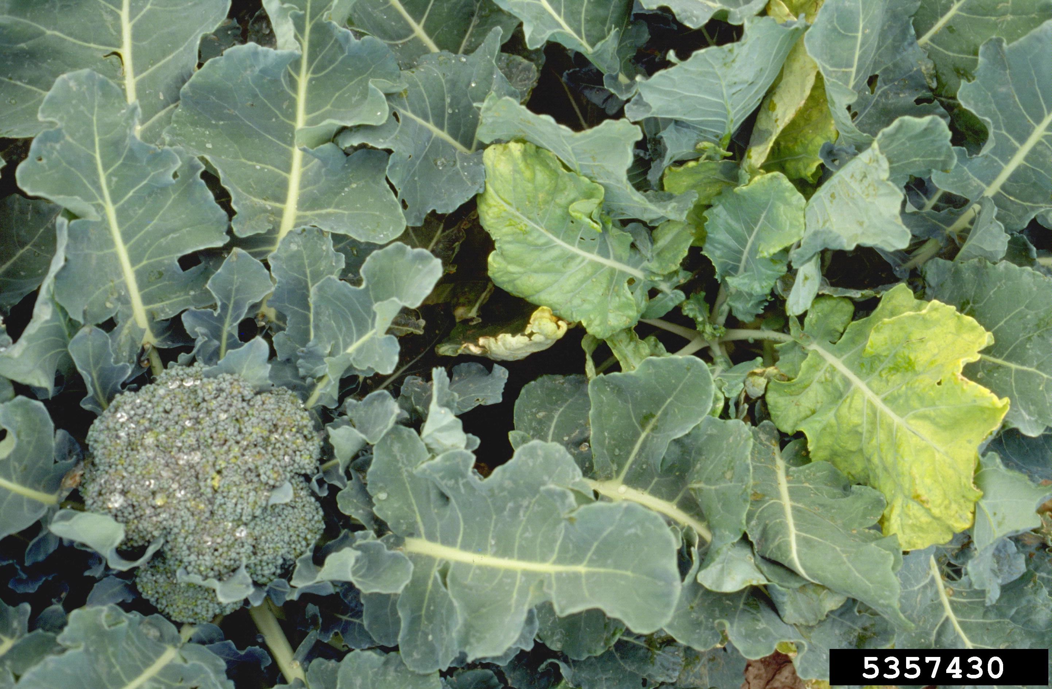
10. You are asked to determine the causal agent of the symptoms in the chlorotic broccoli plant on the right. You examine the symptomatic broccoli plants and find aphids (Breuicoryne brassicae) and the grower tells you that populations of this aphid are high this year.
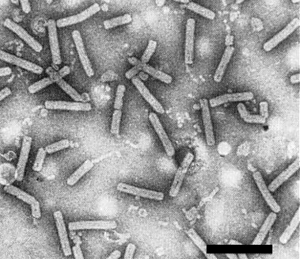
You suspect a virus so you perform a leaf dip using symptomatic tissue. You see the image below in the EM.

A. What type of particle morphology do you see in the image to the right? (2 pts)

B. What family of viruses do you suspect may be present in your plant? (2 pts)

Bar is 500 nm

11. Viruses have to have developed many ways to overcome plant cellular defenses as they infect a cell. Plant viruses in the Reoviridae have an unusual method to protect their genome while they produce transcripts, what is it? (3 pts)

_____/12

12. What role(s) can endogenous plant pararetrovirus sequences play in plant disease? (3 pts)

13. Viruses can move from plant to plant by various means. One means you have learned and used is mechanical inoculation.

- What is mechanical transmission? (2 pts)

- If you are using mechanical inoculation and the results are not very good, state 2 of the most likely aspects/parts/components of the technique that you can adjust to try to improve the results? (2 pts)

13. There are several possible types of interactions possible between a virus and a plant. Distinguish the terms “recovery” from “tolerance or latent” from each other. (3 pts)

14. The ambisense/negative sense ssRNA viruses (Tospoviruses) unlike the plus sense ssRNA viruses, cannot initiate replication by production of a polymerase since their genome cannot function as an mRNA. How do they get around this problem? (3 pts)

15. The ss DNA plant viruses have a similar problem, their genome cannot act as an mRNA either. So where does the polymerase come from to initiate their replication? (3 pts)

_______/16 points

EXTRA CREDIT

Viruses are the most abundant “life forms” on the planet and are considered planetary forces that can effect change on a large scale (http://fora.tv). While this term so far has been applied to bacteriophages it could be argued that it could also apply to plant viruses. Give 2 arguments as to why plant viruses could be considered planetary forces (2 pts)

