MIDTERM EXAM
PLANT VIROLOGY

February 20 2017

Name: ________________

Personal Code No. : ___________

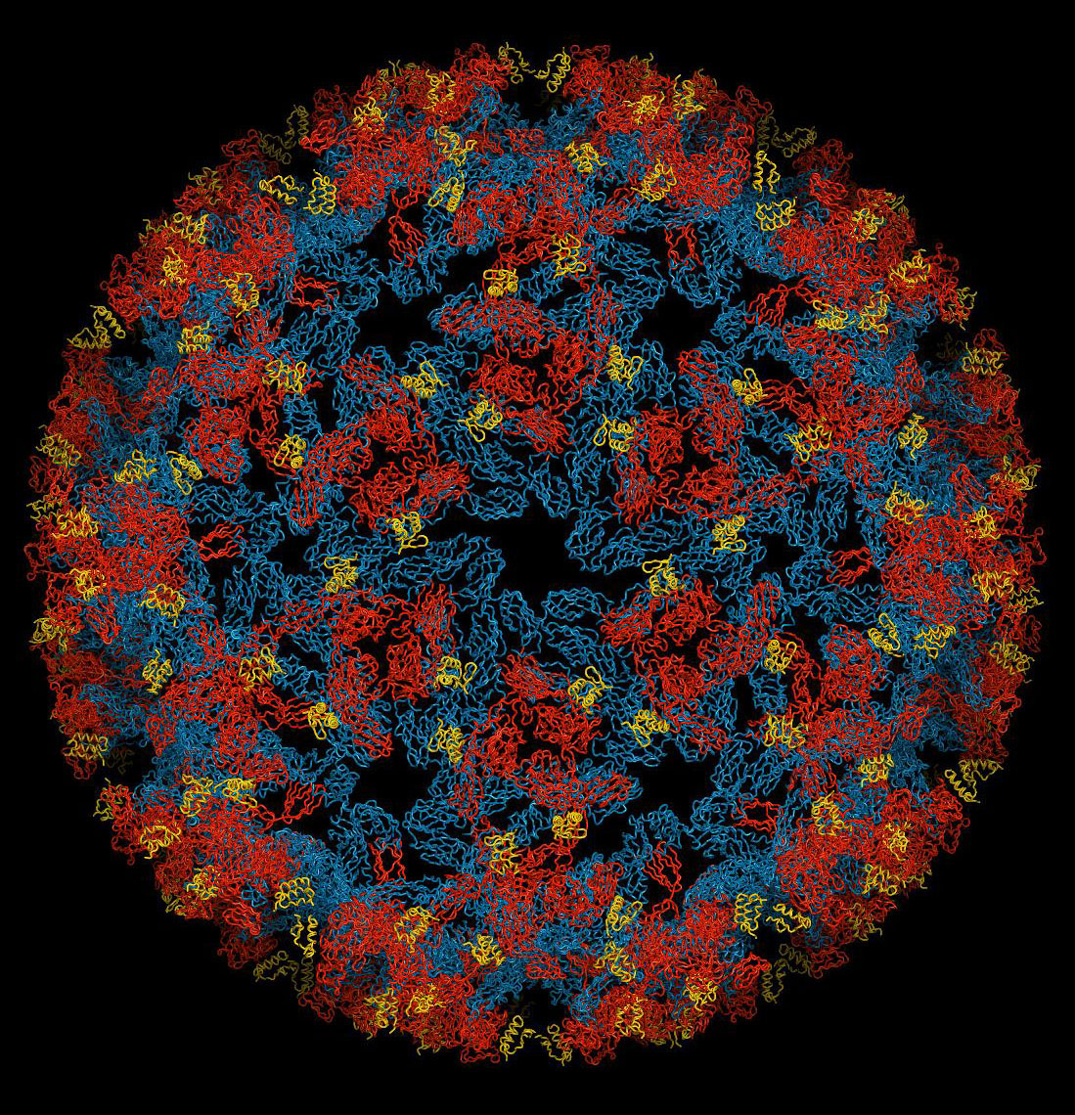
SECTION I. Fill-in-the-Blank (Section totals 26 points).

Fill in the blanks with correct word(s) (2 points for each correct answer)

1. Some viruses have been shown to be capable of integrating parts of or entire genomes and even multiple copies of their genomes into the host’s genome. This is known to occur with at least two plant virus families, name one: _________________.

2. Give two advantages that are conferred by the use of a capsid made of multiple copies of the same molecule? _____________________ and _____________________.

3. The membrane that envelopes some virus genomes are composed of components from two different origins which are: ____________________________________ and ___________________________.

4. Give the name of 2 plant virus families that express at least some of their viral proteins via proteolytic processing, ___________________ and __________________.

5. The ICTV requires that you obtain the complete ___________________________ of a virus before they will consider accepting it as a new virus species.

6. What are the 2 most critical things that shorten the life of plant viruses in long term storage? ____________________ and __________________________.

7. Give examples of two families of viruses (or viroids) for which one or more species are able to replicate in the nucleus: __________________ and ______________________.



8. The image to the right is that of an actual Iphone case showing a high resolution image of a virus. What is the name of the capsid structure shown in green near the center of the image?

____/26
SECTION II. Short Answer (section total 70 pts)

1. Provide 3 characteristics that taken together will distinguish a virus from all other mobile genetic elements? (6 pts)

2. All viruses can be organized into families by several essential characteristics. Describe the types of diversity seen among plant viruses for each of these characteristics: (11 pts)

Types of nucleic acid:
Shape of the nucleic acid:
Strandedness:
Coding sense:
Segmentation:

3. Even though the genera Tospovirus and Cytorhabdovirus have been placed in different families, they have several characteristics in common. Name 3 characteristics shared by virus species in these two genera. (2 pt ea, 6 pts total)

4. Why are genomes of plant viruses that have positive sense RNA genomes often infectious even in the absence of their coat protein? (2 pts)

5. What is meant by the term “viral metagenomics”? (1 pt)

___/26

6. What is one of the advantages of the presence of subgenomic RNAs in the replication cycle of tobamoviruses and many other (+) ssRNA viruses? (1 pt)

7. Viruses can move from plant to plant by various means, one of those means is mechanical inoculation. What is mechanical transmission? (2 pts)

8. Plant virus species are not named using a binomial nomenclature system like fungi or bacteria or plants. How is the name of a virus species created (ie what are the 3 essential components in the approved name of a virus species? (2 pts ea., 6 pts total)

9. You think that you have found a new species of Caulimovirus in tomato based on the virion size and shape (seen with the EM). Since you are familiar with the Caulimovirus replication strategy, give the specific names of 3 proteins that you know that the new virus will have to produce. (1 pt each, 3 pts total)

10. There are 3 types of satellites that depend upon a plant virus for their replication. Name them and distinguish one from the other (6 pts)

11. Give the name of two families of mobile genetic elements that employ a rolling circle mechanism for their replication. (4 pts)

___/22
12. Describe two characteristics that distinguish the 2 families of viroids from each other. Include the differences for each family (4 pts)

13. All viruses can be divided into seven types on the basis of differing strategies for storing and replicating their genomes through RNA and/or DNA intermediates. To date, plant viruses have been found in six of the seven types.

A. Circle the classes of virion contents to indicate which of these are known to have representation among plant viruses (6 pts)

B. Give an example of a virus family for five of the six classes. (indicate with an arrow to connect the name of the family with the class of replication) (5 pts)

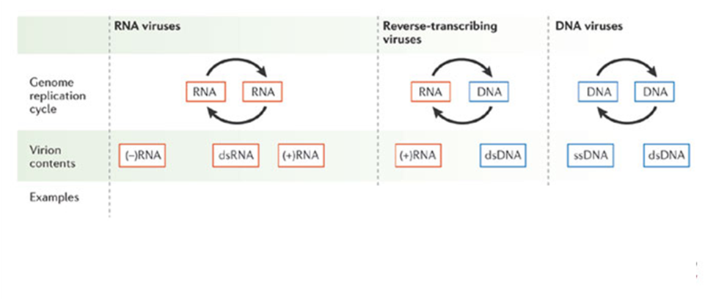

14. There are several possible types of interactions possible between a virus and a plant. Distinguish the terms “immunity” from “tolerance or latent” from each other with respect to virus movement, replication, and symptom expression (3 pts)

_____/18

15. Below is a diagram of the virion of Banana bunchy top virus in the genus Babuvirus, family Nanoviridae. This virus has a multipartite genome composed of 6 to 8 circular ssDNA segments about 1kb in size. Each segment has a common stem-loop region and are encapsidated in a separate particle. (1 pt each, 3 pts total)
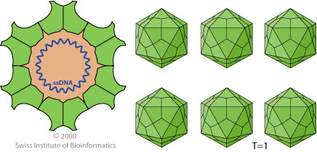



- Circle the virion of this virus (as defined in this course).

- What is the term used to describe the morphology of this virus?

- Although we have not studied this virus, you should be able to infer the origin of the polymerase that this virus uses for the replication of its genome. What is it?

16. In an effort to identify the causal agent(s) of a new disease in purify what I think is a new RNA virus from a symptomatic plant. When I view the purified virus in an electron microscope I see 2 different types of particles, some icosahedral and some that are helical. The icosahedral particles are large (50 nm) and the helical particles are also fairly large (2000 nm). Which of the following hypothesis would explain the reason for what I see and will help me choose the direction of the study? You may defend your choices if you like. (5 pts)

- I have a mixed infection of 2 different viruses
b) I have a virus with a satellite virus
c) I have a virus with a defective interfering DNA
d) I have a virus and a viroid
e) I have a multicomponent virus

____/8 points
EXTRA CREDIT

Agrios defines disease as “Any malfunctioning of host cells and tissues that results from continuous irritation by a pathogenic agent or environmental factor and leads to development of symptoms.” (2 pts)

Is a latent infection of a virus in a plant a disease? Defend your answer.

