MIDTERM EXAM
PLANT VIROLOGY

JUNE 11 2018

Name: ________________

Personal Code No. : ___________

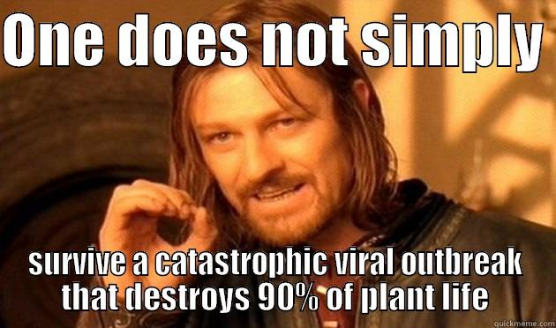
SECTION I. Fill-in-the-Blank (Section totals 20 points).

Fill in the blanks with correct word(s) (2 points for each correct answer)

1. Some plant viruses, such as Tomato spotted wilt virus (Orthotospovirus) are neither icosahedral nor helical in shape. The shape of this virus is known as
________________________________.

2. Give two advantages that are conferred by the use of a capsid made of multiple copies of the same molecule? _____________________ and _____________________.

3. DNA sequences of pararetroviruses (Caulimoviridae) can be found in plant cells as two very different forms. What are those two forms?
_________________________ and ________________________________.

4. Give the name of 2 plant virus families that express at least some of their viral proteins via proteolytic processing, ___________________ and __________________.

5. This family of viruses has 2 or 3 capsid protein shells. __________________

6. Some viruses have been shown to be capable of integrating parts of or entire genomes and even multiple copies of their genomes into the host’s genome. This is known to have occurred with at least two plant virus families, name one: __________________________.

7. When is it correct to write the names of virus species in italics?
______________________________________________________________

____/20
SECTION II. Short Answer

- Some viruses have monopartite virions and others have multipartite virions.

- What advantage (that you learned in class) does having a multipartite virion give these viruses? (2 pt)

- Most of the families and genera in the Bunyavirales and Mononegavirales are composed of viruses with an envelope.

- List 2 plant virus families that have an envelope (4 pts)

- What is are the two main sources for the composition of the viral envelope? (2 pt)

- What is the purpose of the envelope? (1 pt)

3. Plant virus species are not named using a binomial nomenclature system like fungi or bacteria or plants. How is the name of a virus species created (ie what are the 3 essential components in the approved name of a virus species? (1 pt)

4. Give 3 examples of virus families whose members are true viruses but lack pentamers and hexamers in their virion structure? (2 pts each/ 6 pt total)

5. Describe two characteristics that distinguish the 2 families of viroids from each other. Include the differences for each family (4 pts)

___/20
5. There are 6 categories of mobile genetic elements. (10 pts total)

- Which of them can induce phenotypic changes (ie symptoms) in plants? (circle all that apply)

Plasmids Viruses Viroids Transposons Prions Satellites

- Which of these can replicate autonomously in plant cells?

Plasmids Viruses Viroids Transposons Prions Satellites

- Sequences of which of these can be found in plant genome sequences?

Plasmids Viruses Viroids Transposons Prions Satellites

6. All viruses can be organized into families by several essential characteristics. Describe the types of diversity seen among plant viruses for each of these characteristics that we covered in class: (11 pts)

Types of nucleic acid:
Shape of the nucleic acid:
Strandedness:
Coding sense:
Segmentation:

7. You see unusual virus-like symptoms in pumpkin plants in Florida. You collect a sample from several plants and perform a leaf dip and see virus-like particles in the TEM.

- What two characteristics of the virus would this provide you? allow you to place it in the appropriate virus family. (2 pt)

- Is this enough information to identify the family of the virus? Give at least one example to defend your answer (2 pt)

___/25
8. Why are genomes of plant viruses that have positive sense RNA genomes often infectious even in the absence of their coat protein? (2 pts)

9. Viruses in the family Caulimoviridae code for the enzyme reverse transcriptase. (1 pt each, 3 pts total)

- In general what does reverse transcriptase do?

- How is it used by caulimoviruses?

- Which other group of mobile genetic elements also codes for RT?

10. We read 2 papers on viral metagenomics in class. (1 pt each, 2 pts)

A. What is meant by the term “viral metagenomics”?

B. What is one of the impacts of viral metagenomics in plant disease management?

11. What is one of the advantages of the use of subgenomic RNAs in the replication cycle of (+) ssRNA viruses? (2 pt)

12. Reoviruses have an unusual means of replication within the cytoplasm of their host cells. (1 pt each, 2 pt total)

- Specifically, where does replication of progeny viral genomes occur?

- What is the advantage of this for these viruses?

___/11

13. There are 3 types of satellites that depend upon a plant virus for their replication.

- List them and distinguish one from the other (6 pts)

B. What roles can these satellites play in plant disease? (2 pts)

15. All viruses can be divided into eight types on the basis of differing strategies for storing and replicating their genomes through RNA and/or DNA intermediates. To date, mobile genetic elements found in plants have been placed in seven of the eight types. (7 pts total)

A. Circle the classes of virion contents to indicate which of these are known to have representation among plant viruses

B. Give an example for each of the classes. (be sure to connect the example with the class of replication)

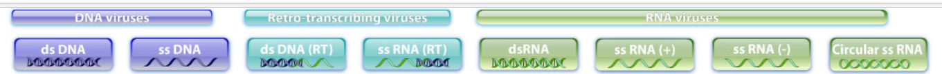

___/15
15. There are several possible types of interactions possible between a virus and a plant. Distinguish the responses known as “susceptible” from “local lesion” from each other with respect to virus movement, replication, and location of symptom expression (6 pts)

16. Below is a diagram of the virion of Satsuma dwarf virus in the genus Sadwarvirus, family Secoviridae. (1 pt each, 3 pts total)

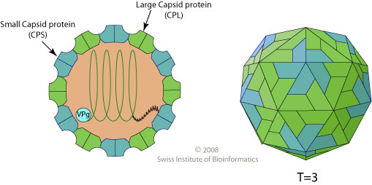

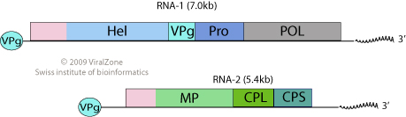

- What is the type, sense and strandedness of the genome of this virus?

- Is the genome monopartite or multipartite?

- Is this virion monopartite or multipartite?

____/9 points

EXTRA CREDIT

This is an artist’s rendering of a virus particle from a family that we studied. (1 pt each, 2 pt total)
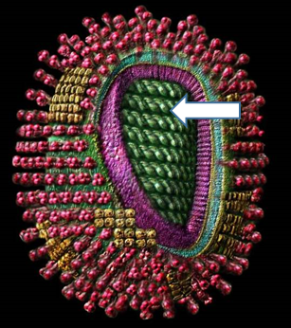
- Which family does this most closely resemble?

- To what protein is the arrow pointing?

