**Guidelines**

**Mushroom/ Conch Identification Sample Collection Guidelines**

**1) Collect and Store the Sample**



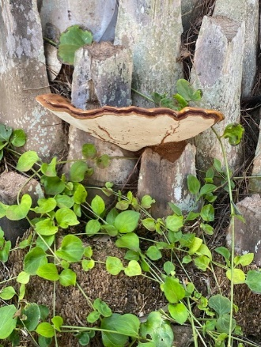Mushrooms and other fungi rot quickly so they need to be packaged and shipped properly.

* Before collecting the sample, please take photos of how the mushroom grows on or near the plant and send them via email to [pdc@ifas.ufl.edu](mailto:pdc@ifas.ufl.edu). The photos to the right are examples of adequate photos to send.
* Conchs are recommended to be greater than 4 inches for better identification.
* Dry your mushroom sample prior to sending it. Mushrooms should be sliced carefully from the ground or host plant and then placed in a food dehydrator or in front of a fan in a dry room. Most fungi will take at least 24-48 hours to dry.
* Never store a fresh mushroom in a plastic bag because it will quickly degrade. Paper bags are best for short term storage of mushrooms.
* Make sure your mushroom is totally dry before you package and send it. This preserves its quality and increases our ability to identify it.
* Place your mushroom in a paper packet or envelope in a padded box to protect the samples during shipping.

**2) Fill Out the Submission Form**

* For conchs on palm hosts, please use the palm submission form. For all other hosts, please fill out the general submission form. Both forms are available at <https://plantpath.ifas.ufl.edu/extension/plant-diagnostic-center/>.
* Please provide as much information as possible. You are encouraged to include any other pertinent information in addition to that on the form.
* If no payment information is provided on the form or with the sample, the submitter will be invoiced $40 via email. Complete payment is due before a report can be provided.
* Please place the submission form in a separate bag from the conch/mushroom to prevent degradation of the form.

**3) Send the Sample Promptly**

* Ship or deliver samples directly to the UF PDC. It is recommended to use an overnight courier service with sample tracking to retain sample quality and expedite sample processing.
* Mail samples early in the week to avoid the weekend layover in shipping.