**Palm Sawdust Sample Collection Guidelines**

Pathogens the UF PDC can test for with sawdust: Lethal Yellowing and Lethal Bronzing (aka Texas Phoenix Palm Decline), Fusarium Wilt, and Thielaviopsis (updated 12-2024)

**1) Collect and Store the Sample**

* Email [pdc@ifas.ufl.edu](mailto:pdc@ifas.ufl.edu) before you collect a sample for submission for recommendations on the appropriate type of sample and tests based on your description of the palm and its decline.
* Before collecting the sample, please take photos of the whole palm, symptomatic tissue, crown (head of the palm, where the fronds are), and the surrounding landscape. Send the photos via email to [pdc@ifas.ufl.edu](mailto:pdc@ifas.ufl.edu).
* Collect sample prior to OTC injections.
* Do not sample dead palms; we cannot guarantee recovery of pathogens from dead tissue.
* You will need the following materials and tools to collect your sawdust sample:
  + 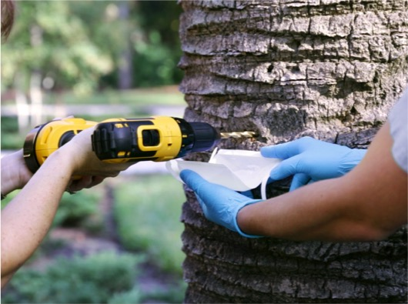Portable electric drill with 10in long x 5/16in diameter drill bit; longer is better for Phoenix palms
  + Clean, self-sealable plastic freezer bags (e.g., Ziploc bags)
  + Bottle of water
  + Golf tees or 5in wood dowels to fill the hole made by the drill bit
  + Hammer to tap golf tee or dowel into hole
  + Portable propane torch if you will be sampling more than one palm

1. If you have sampled palms recently with this drill bit, flame sterilize drill bit by running and twisting it slowly through a propane torch flame to remove debris/DNA on its surface.
2. Allow bit to cool by squirting with water.
3. Drill a hole into the trunk of the palm. Bore the hole at chest height or lower on the trunk for cosmetic considerations. Collect at least 2 tablespoons of interior wood shavings from the hole. Do not touch the shavings with your hands as this can contaminate the sample. See picture above for an example of the procedure.
4. For Phoenix palms or other palms with “bark”, drill past the old leaf bases to obtain trunk tissue (the pseudobark and dead leaf bases do not contain pathogens).
5. Avoid collecting wet and discolored (reddish-brown) shavings that are decaying. Decayed samples are less reliable.
6. Label the bags of shavings with palm identifiers such as species, location, and date collected.
7. Once sawdust is collected, insert a golf tee or wooden dowel into the sample hole and tap it flush to the trunk with a hammer. This should seal the hole and prevent copious sap bleeding while preventing penetration of pests or other unwanted potential pathogens.
8. After obtaining the shavings from one trunk, rinse the drill bit with water to remove debris.
9. If you plan to sample additional palms, flame-sterilize the bit with a propane torch and cool with another squirt of water. This must be done before boring a hole in a different palm trunk to avoid cross-contaminating tissue samples and potentially spreading disease.

* 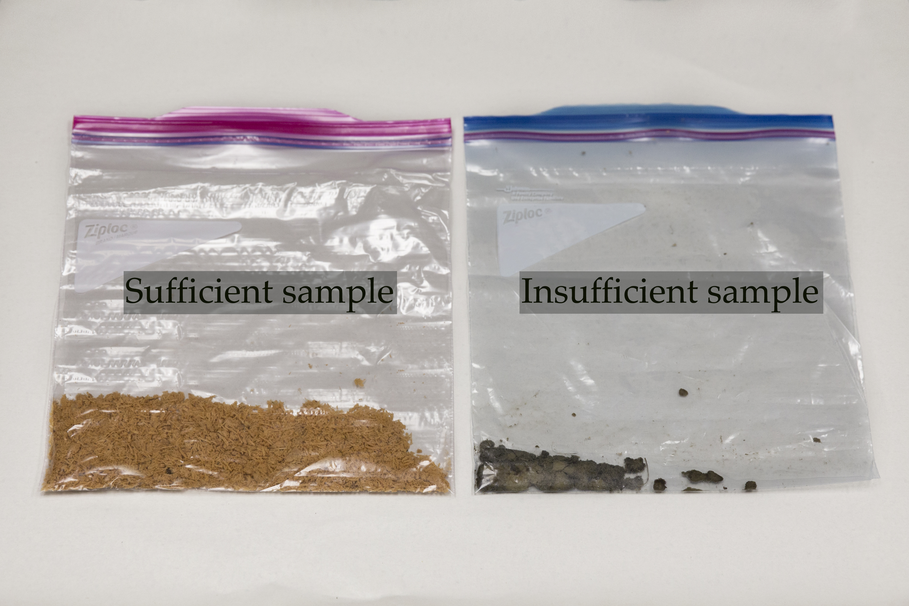If you would like to pool multiple samples (up to 10) into one sample for one result, we still request that you take individual palm samples in separate bags. We will subsample from the samples you submit. We can then discuss testing samples individually if you have a positive result from the pooled sample. We will keep the samples separate for additional testing so no resampling is necessary.
* Submit generous amounts of sawdust. Keep samples refrigerated after collection until they are submitted. We are only able to test/process a sample with adequate living tissue. See photo to the right for characteristics of a sufficient and insufficient sample.
* For Ganoderma conch collection, please refer to our Mushroom/ Conch Collection Guidelines.

**2) Fill Out the Submission Form**

1. **Fi**

* For all palm samples, please fill out the palm sample submission form. All samples must be accompanied with this complete Sample Submission Form.
* Please provide as much information as possible, especially age of planting and when symptoms started.
* Multiple services are available for palms, please see the pricing guidelines below and our price sheet on current fees.

|  |  |
| --- | --- |
| PRICING GUIDELINES | |
| $80 | PCR for detection of palm phytoplasmas (LY, LB) AND culturing for Thielaviopsis and Fusarium (sawdust required) |
| $60 | PCR for detection of palm phytoplasmas only (sawdust required) |
| $40 | Culturing only (no PCR) for Fusarium, Thielaviopsis, and rachis rot (sawdust required for Fusarium and Thielaviopsis, rachis required for rachis rot) |
| $40 | Identification of conch for Ganoderma (conch required) |
| $100 | Pool up to 10 samples together for PCR for palm phytoplasmas only; get one result for the whole batch (sawdust required) |

* If no payment information is provided on the form or with the sample, the submitter or person indicated in the billing section will be sent an invoice via email. Complete payment is due before a report can be provided.

**3) Send the Sample Promptly**



* Ship or deliver samples directly from the grower/site to the UF PDC. It is recommended to use an overnight courier service with sample tracking to retain sample quality and expedite sample processing.
* Mail samples early in the week to avoid the weekend layover in shipping.
* Samples are processed on a first-come, first served basis in most cases. The exception to this rule is our rush service. Rush services include the sample(s) being processed immediately upon delivery, moved to the front of the sample line, and communication within 2 business days to report preliminary results. There is a flat fee of $50 added per sample. Please see our price sheet for more information.